1. Coordinate Systems

First let us talk about coordinate Systems

1. Number Line System which is our X axis, and we can move on it back and forward using addition and subtract operations. And it is mainly used in one dimension (D =1)
2. Cartesian Coordinate system, which have two axis X and Y, witch gave us a way to add two more operations (multiplications and divisions), so we can represent the operations for (+,-,\*,/). Which is mainly used in two dimensions (D =2)

Then we moved to third dimension (D =3), so used another extra axis Z, and to this gave us the pliability to represent more complex operations and visualize more complex shapes. Which is called spherical coordinate systems, which has three parameters one for each axis, represented by (r, θ, φ), where r is the distance from the origin (0,0,0).

And this extension in dimensionality can continue to N-Dimension, and because of the complexity that comes with the increasing in dimensionality because we will need N parameter. Then came the concept of Euclidean Space, to reduce the complexity again and reduce it to 2-D again using the complex plane to represent more complex dimensions in 2-D plane and do not lose the dimensionally as well.

Complex plane has two axis X and Y. but they are totally different from Cartesian coordinate systems X axis and Y axis.

Complex plane X, Y axis are used to represent more complex dimensions but flatten in 2-D. so basically, we use Y axis for folding Dimensions. Every time the dimension increased by 1, we use Y axis to fold the dimensions to reduce our dimensions again to 2-D which our complex plane.

And we still going to use complex plane X axis to get our operations Zeros, as we do in the Number Line System.

In complex plane we use imaginary unit number [i] which it is an imaginary unit in the folded higher dimension. And in our 2-D plane (complex plane) we only see the current folded 2-D from this higher dimension. And because we have two axis (X, Y) we need two parameters as well, these two parameters are (r, θ), where r is the vector length from the origin (0,0) and θ is the angel for this Vector on 2-D (complex plane).

1. Operations in Complex Plane

Based on the introduction complex plane folding, this means that in complex plane we can represent 1-D without any issue in shapes because it is less dimension than the complex plane itself.

Figure (1): we can represent f(X) = X without any issue.

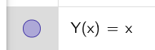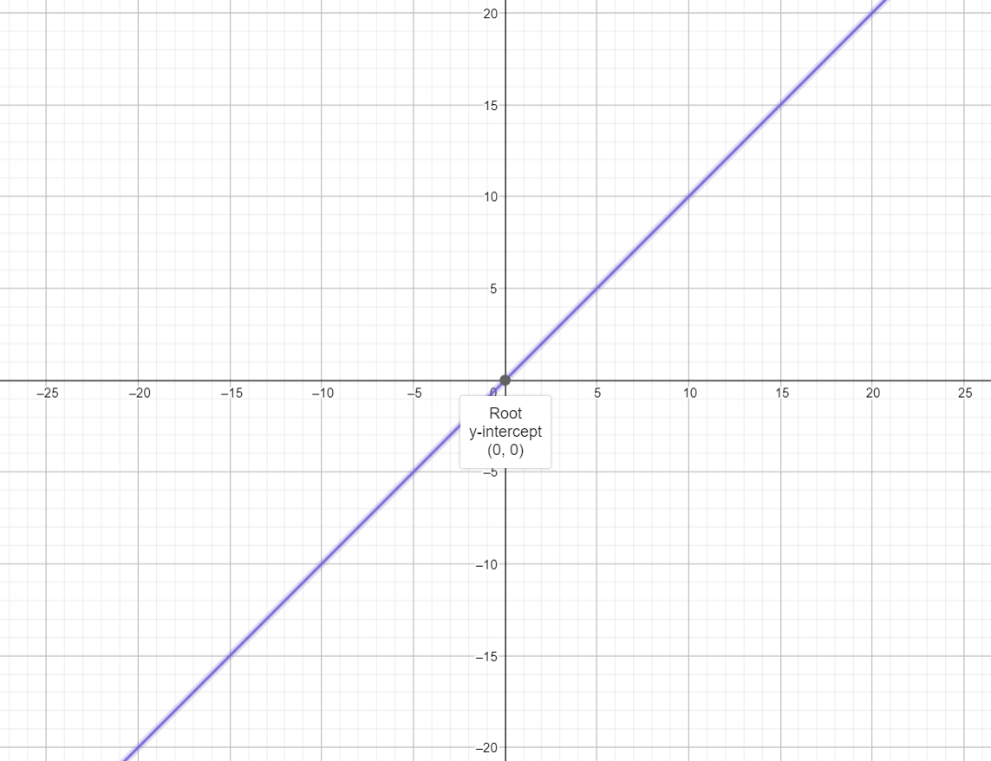

What about if we go one dimension higher to 2-D.

To represent Y = X as 2-D in complex plane. Like the cartesian plane we used same operations (+, -, \*, /).

And in complex plane we have imaginary unit [i] so we will use (Y = i X) as multiplication operations

Or (Y = i + X) as addition operations. We get square because it is 2-D, and the size of the square is 10 by 10 because or number system is base 10 number system.

We get symmetric square over both X and Y axis. Intersects Y at (10, -10) and intersect X at (10, -10). And square have 400-unit squares. With 420 interstation points. 20 of them will be on X axis itself which are our Zeros.

And this symmetry will allow us to only study one quarter of this square and for sure with some operations we can mirror this quarter to the rest of the plane with the same simple operations (+, -, \*, /).

Figure (2): multiplication operations; multiply X by imaginary unit to upgrade from 1-D to 2-D.

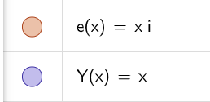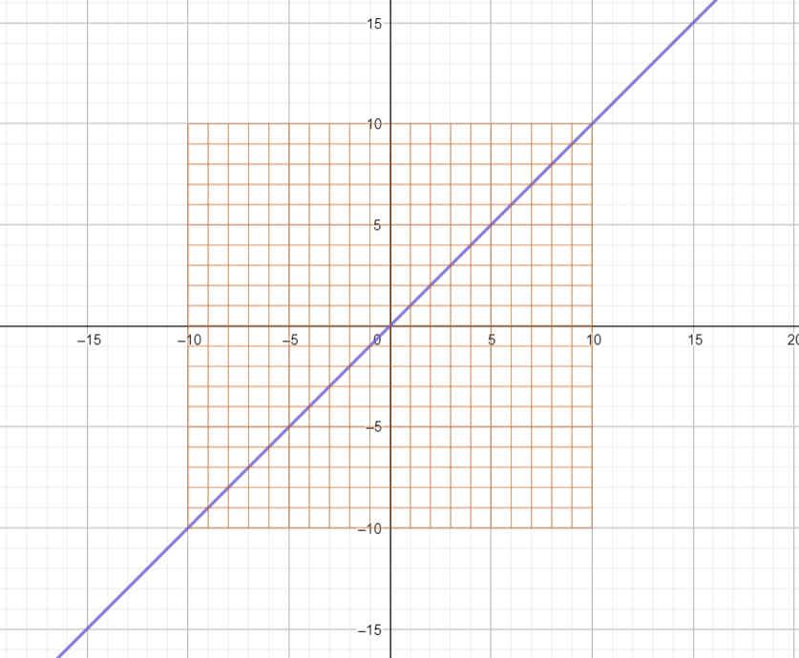

To elaborate more on the operations on the complex plane. We will see the addition operations on complex plane

It is basically shifted the square up by one imaginary unit, now the square intersects Y axis at (-9, 11) and X axis still at (10, -10). But now Y = X is not our square diagonal.

To realign our unit square back to Y = X as diagonal we need to shift X by 1 to align with the new Y intersect at (-9,11).

Figure (3): Shift only in Y direction (Y =X + i).

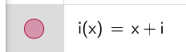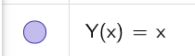

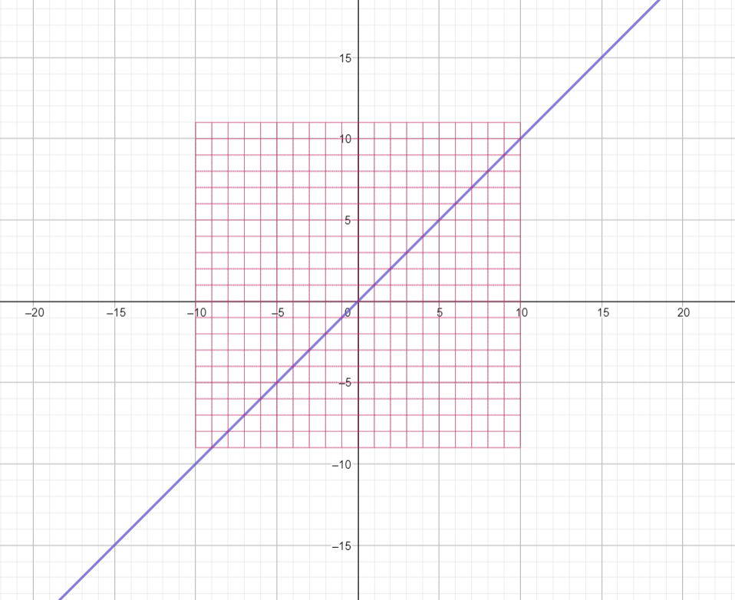

Figure (4): Shift in Y direction (Y =X + i) and in X direction (Y = X + 1 + i).

As a result, Y=X is again at square diagonal, but our square now intersects Y axis at (-9,11) and intersects X axis at (-9 ,11).

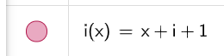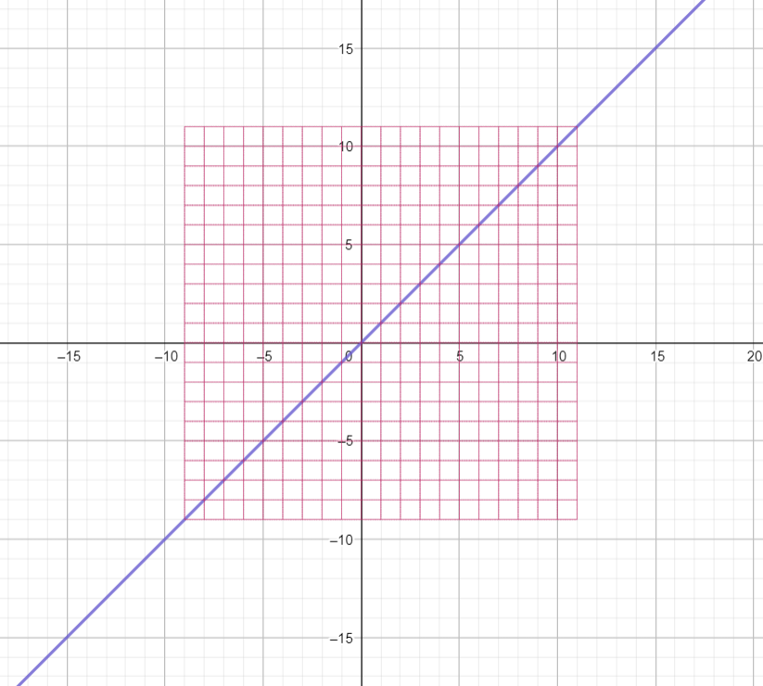

We are going to use the addition operations only because it did not change the X axis or did nay shift in it. So, we are going to us this transformation (Y = X + i). but we still have will have the issue of the shifted square diagonal one unit from Y = X. square intersects Y axis at (-9,11) and intersects X axis at (-10, 10).

Figure (5): shows upgrade Y =X to 2-D using (g(x)= X +i) and how the square diagonal is shifted by one.

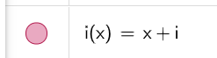 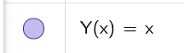 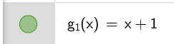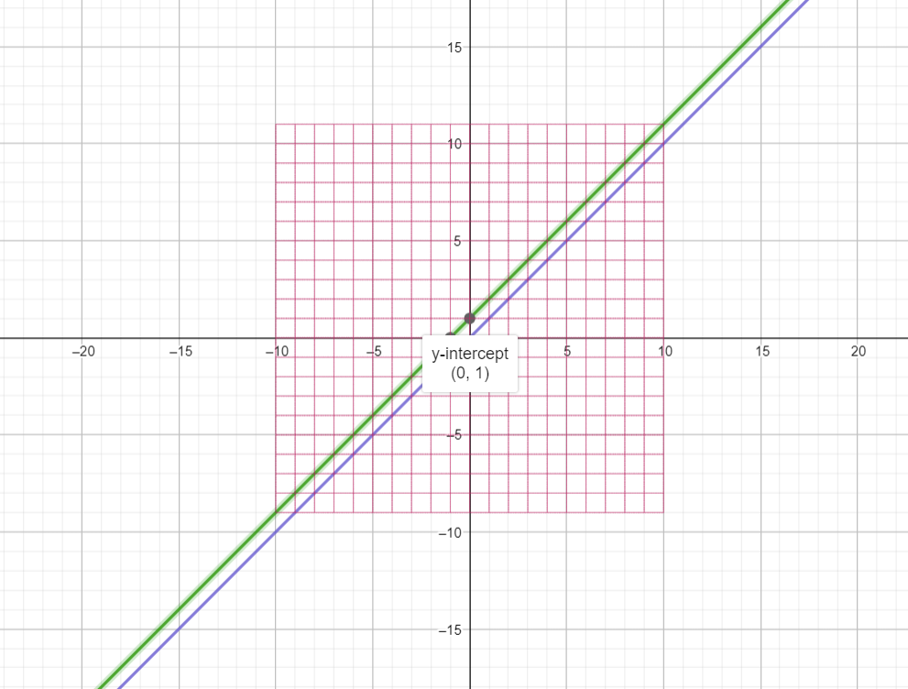

As we now agreed on what operations we are going to use to upgrade from 1-D to 2-D and what issues we need to take care of in our moving between dimensions while we are folding and unfolding dimensions in complex plane.

1. Manifolding in complex Plane

As we explained in the introduction for complex plane, Y axis is used for folding the higher dimensions to reduce it back to 2-D, the dimensionality of complex plane.

So, we are going to introduce one parameter in our complex plane to represent the folding for this 2-D square in complex plane. Which is basically we are doing increase in dimensionality from 2-D into higher dimension.

Our new parameter S will be the folding parameter or in other words will be the dimensionality variable in our complex plane.

Figure (6): folding in complex plane.

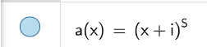

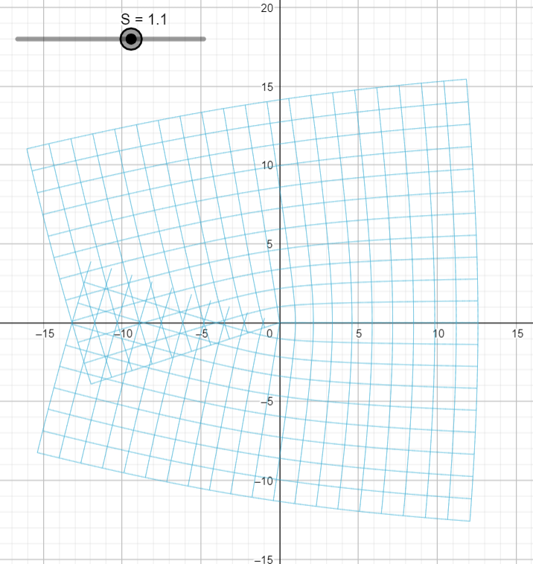

[S] is our folding parameter takes any real values +ev or -ev. Increase in S means going up in dimensionality and means folding in complex plane to be reduced to 2-D. decrease in S means unfolding in complex plane.

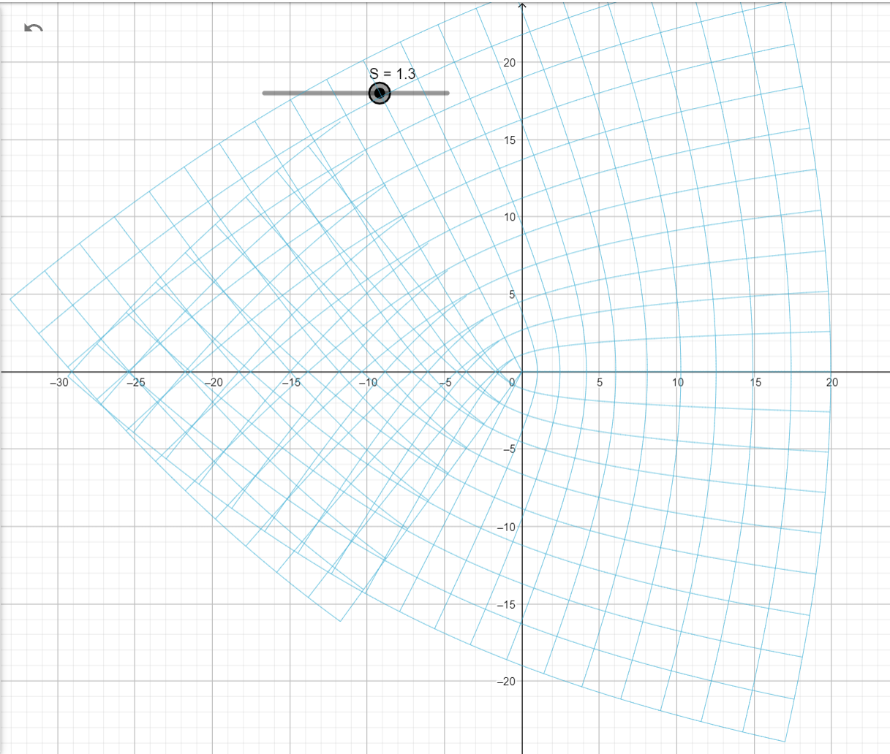

Figure (7): increase dimensionality by increasing [S = 2] and folding our frame of reference from higher dimension back to 2-D in complex plane.

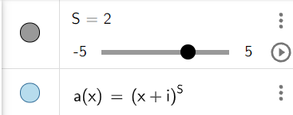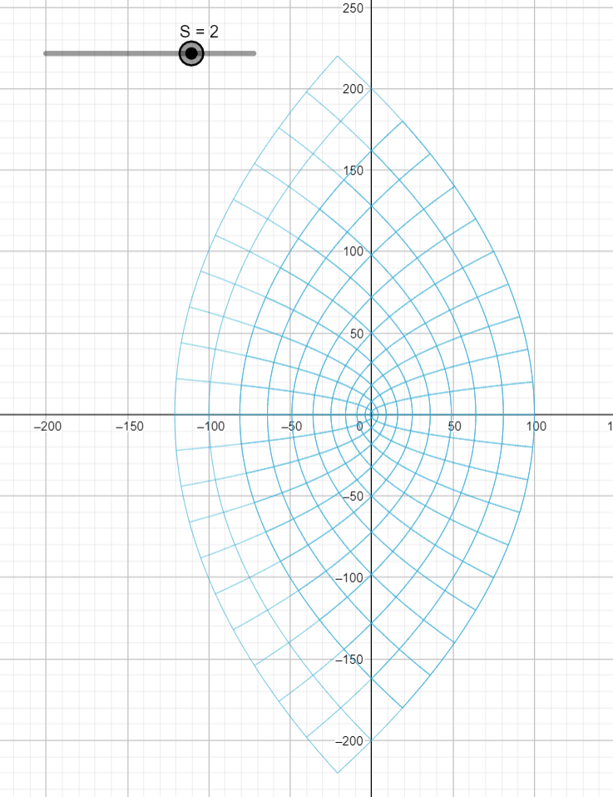

As we see we still have the shift issue we faced for the square diagonal in in 2-D. because Y-axis is not on the tip point of the folded shape.

And as this is for value S = 2 then this means in one axis it is equivalent to $Y= X^{2}$

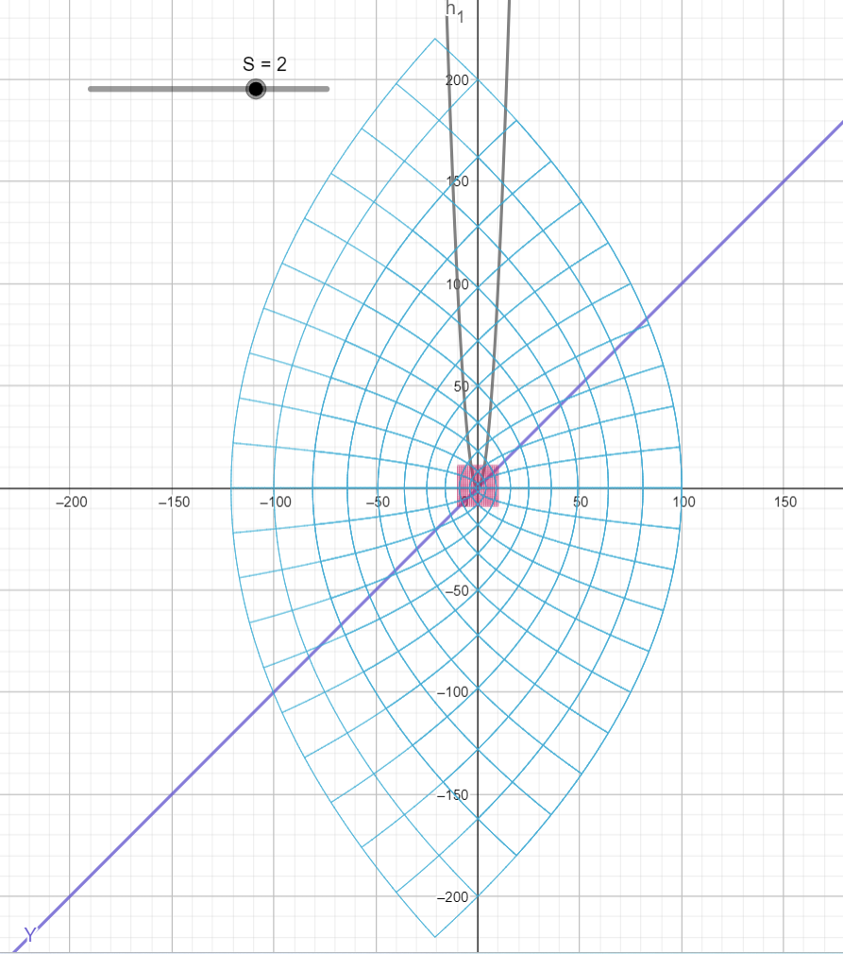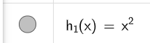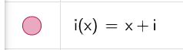Figure (8): include both versions 1-D shapes and 2-D shapes for our simple function Y =X and its transformation in complex plane.

Ok looks like $Y= X^{2}$ is still have the same shift issue that was with Y= X when we raised it from 1-D to 2-D it is will not shifted one unit from the tip of the folded shape. In order to make the Y = X which will make our tansformation one-to-one. Is to fold Y = X in higer dimention with this transformation $Y=\frac{X^{2}}{2}$

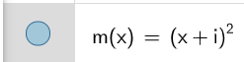Figure (8): shows the correct transformation to keep one-to-one ralation in higer dimnesion after doing one fold extra. To keep Y=X at the tip of the transformed shape, Which fixes the one unit shift issue we expleined before for our squre 2-D diagonal.

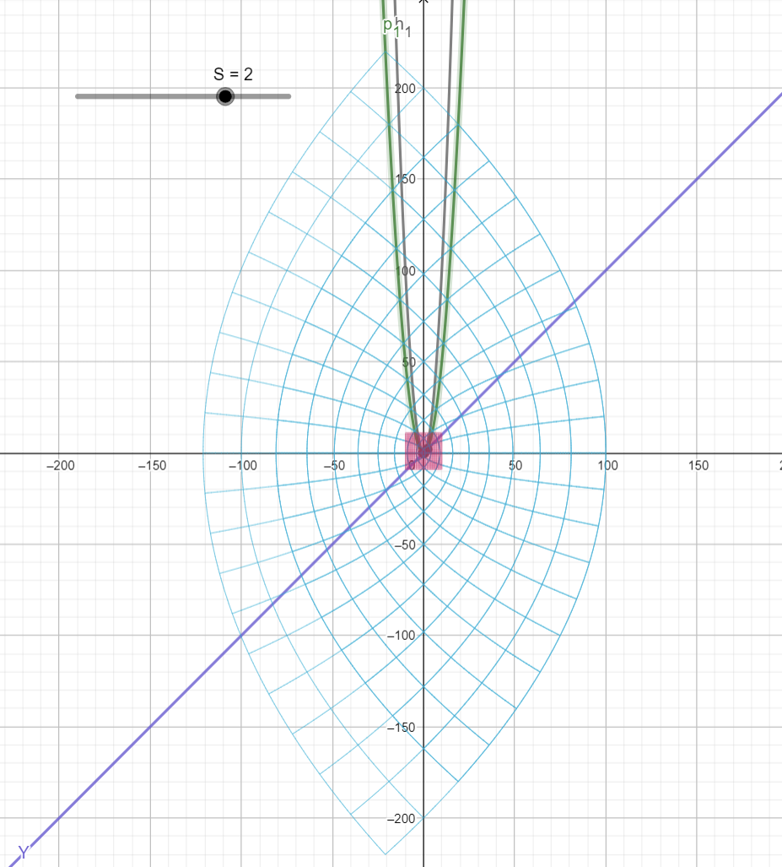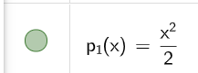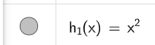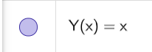

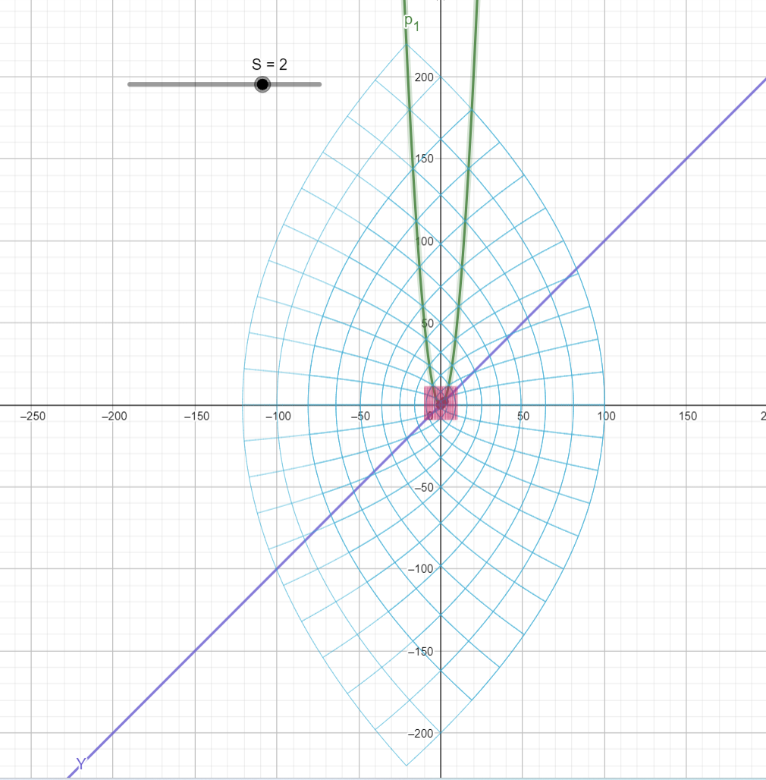

Next, we are going to move on to explore more higher folding (higher dimensions) in complex plane. And what transformation will e needed to keep the one-to-one transformation between dimensions.

Figure (9): increase in [S =3] folding and dimensionality in 2-D. the full view of the folding is in zoom range on 10 to the power of S because we are at base-10 system. So will be in X range values 1000.

In this Figure it is clear also that the same shift unit still exists even in [ S=3] the one-to-one function Y=X is one unit square away from the shape tip point in top right corner.

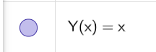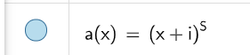

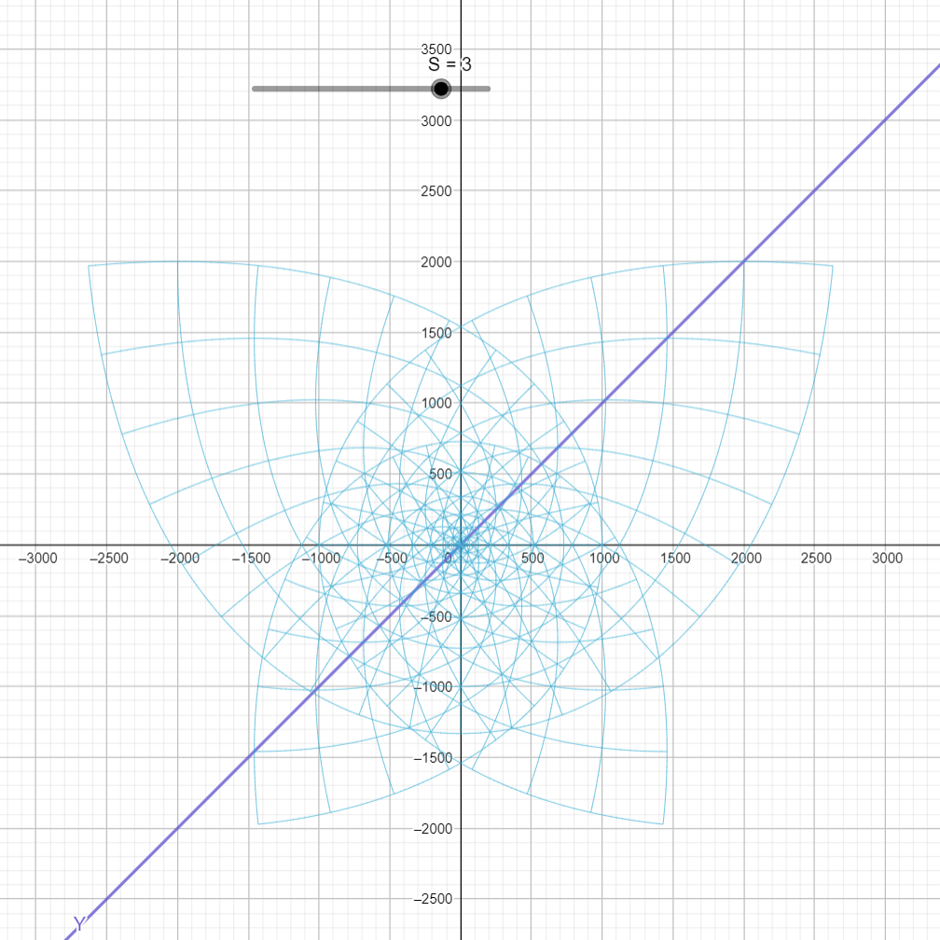

Figure (9): As we zoom in (going towards less values in X) folding the line binding is more aggressive if the line is close to the Y axis and lines away from Y axis are less banded. And we can see some circles starts to emerge due to lines binding and intersections during the folding.

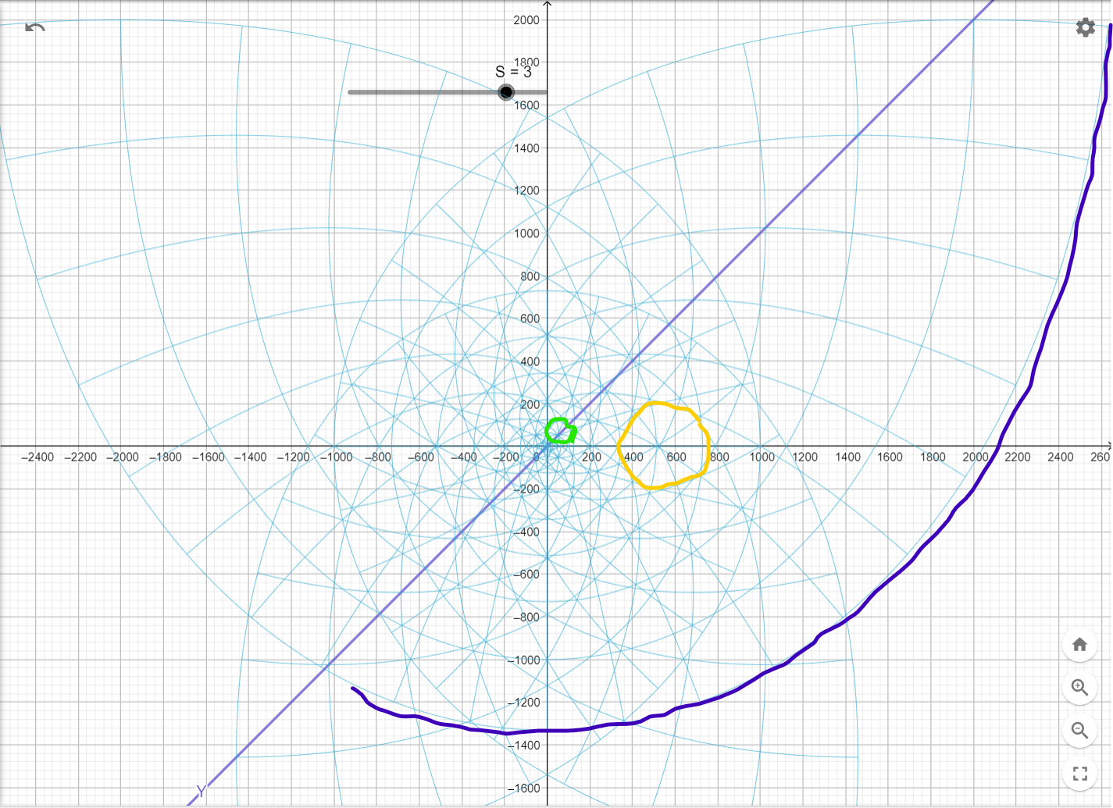

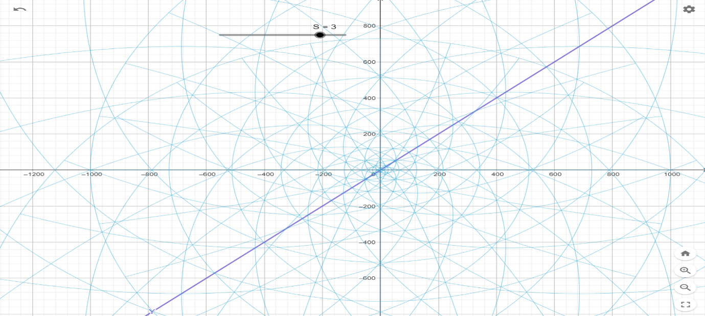As we said before the zeros will be on X axis all the time for any function Y., so each point intersects with X axis is a Zero for one function if we are keeping the one-to-one relationship in our transformation.

Figure (10): S =3 we will have one circle for each line in our square intersect with X axis at X to the power of S.

So, at x=1 we will have one circle intersects with X at (1, -1). At X=2 we will have one circle intersects with X axis at (8, -8) and at X=8 we will have a circle intersects with X axis at (512,512) and at X =9 we will have a circle intersects with X axis at (729 ,729).

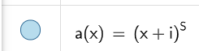

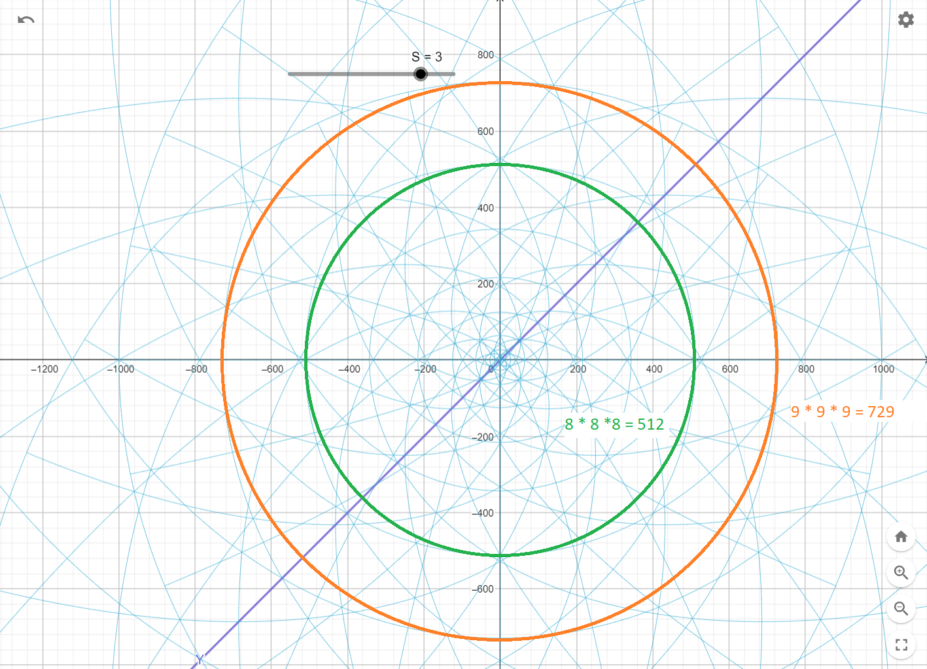

Figure (11): As we go lower and lower in X value i.e., goes towards X = 0, we will go to X =1 the first line in our square and because it is the closest one to Y axis it is will be the most bounded line due to folding. And max shape for folding you can get is a circle in 2-D so for sure for any value for S we will have one circle at the center at origin (0,0) this circle is a unit circle for line X =1 and for any folding for any real value S >= 3.

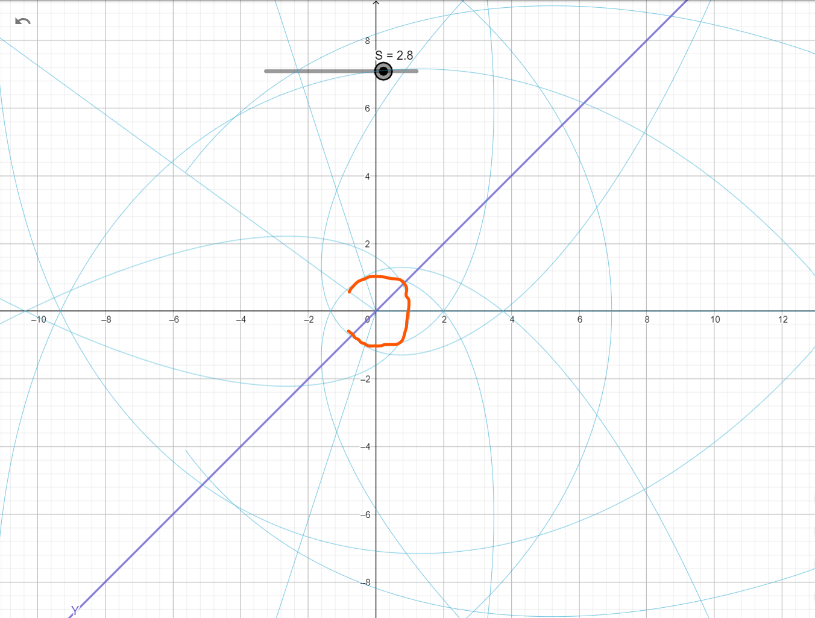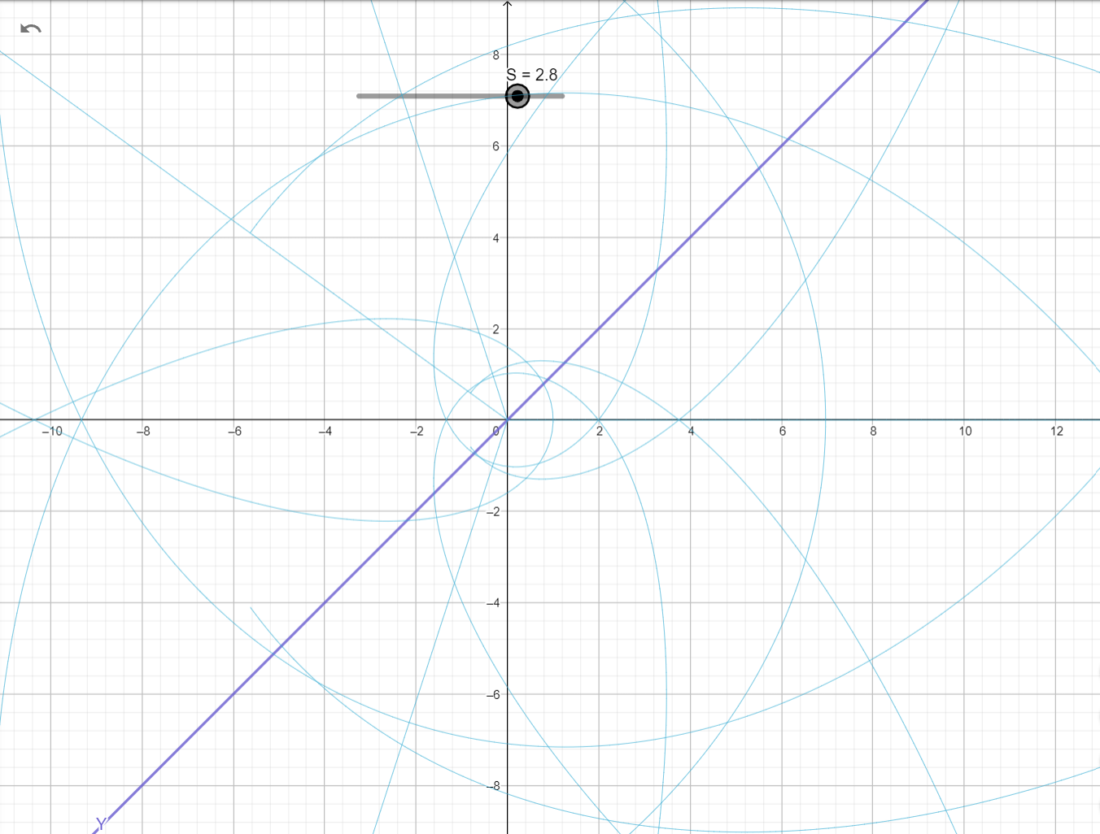

Figure (12): once S =3 all 4 parts of one quarter of square complete a full spine completing the unit circle of complex plane.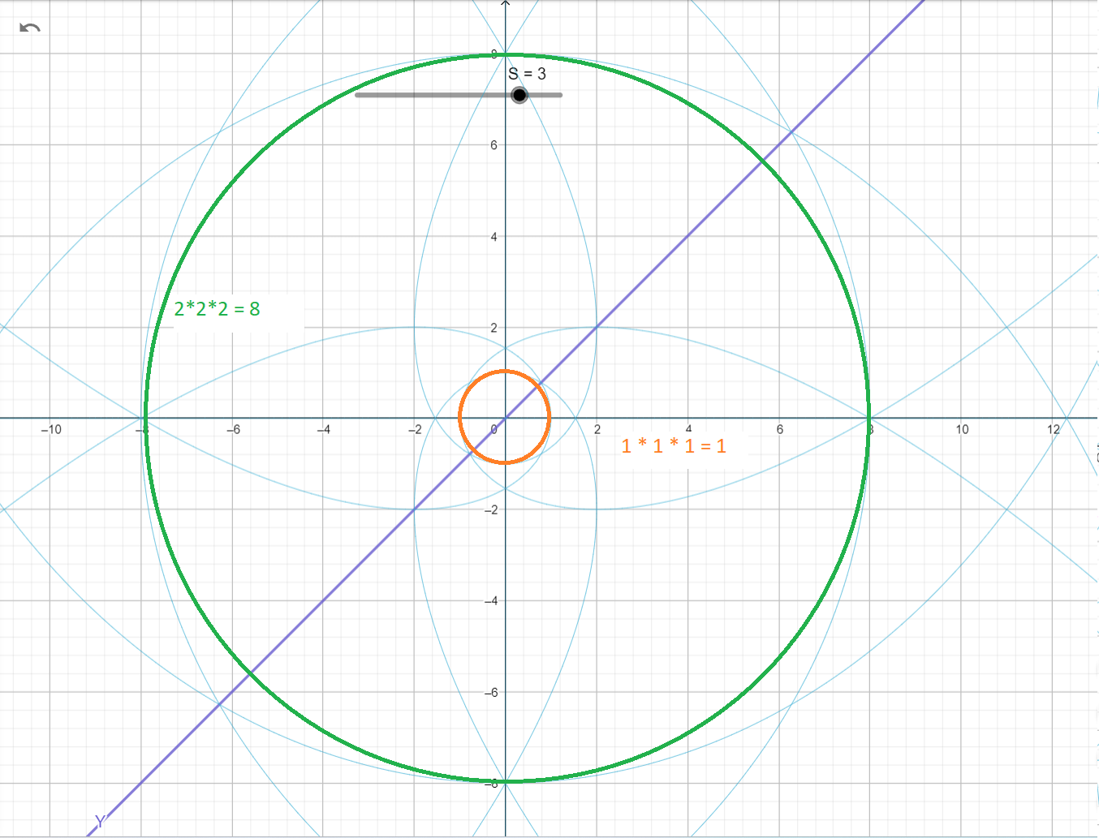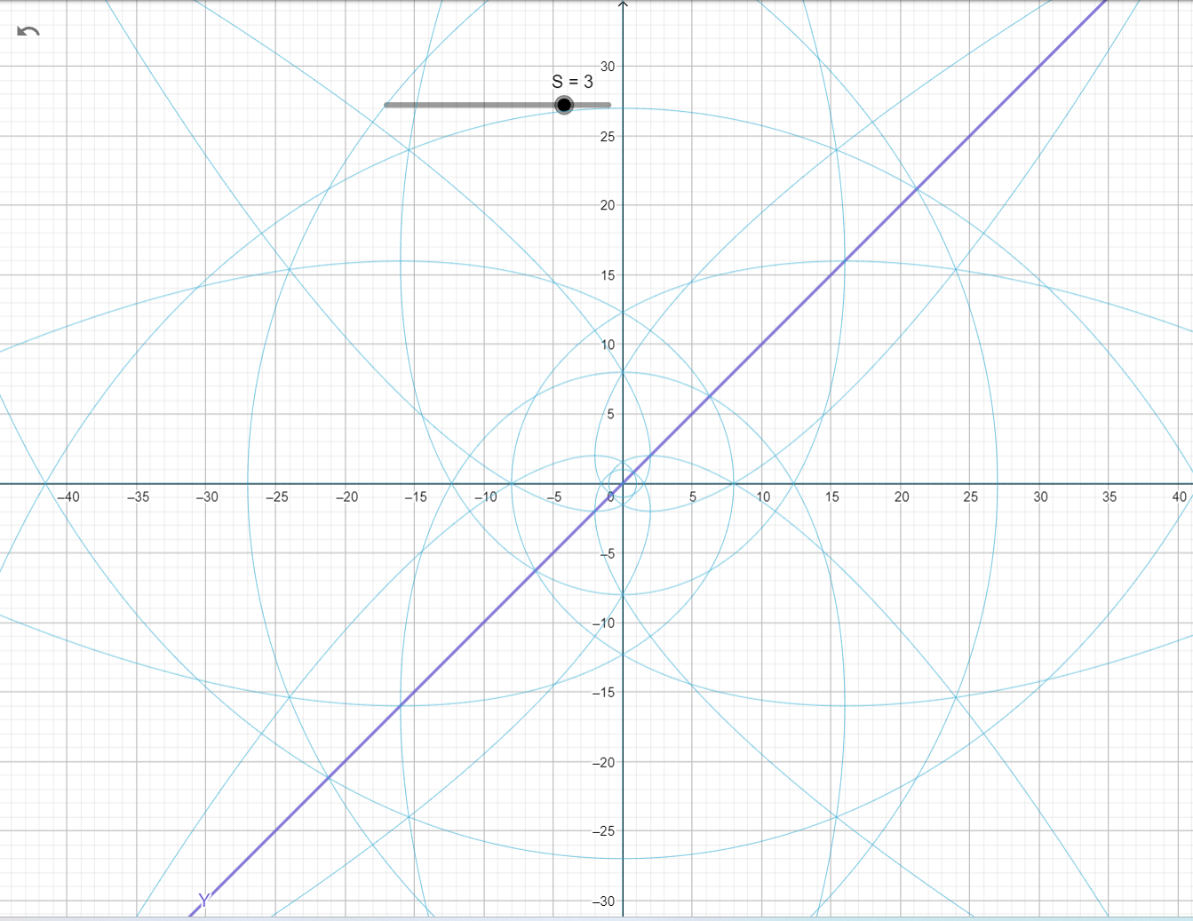

Figure (13): shows the same effect of S but with 1/S and how line X=1 still banded to intersect with X axis at X=1 on the unit circle.

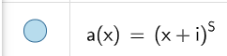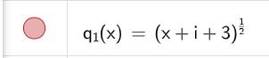

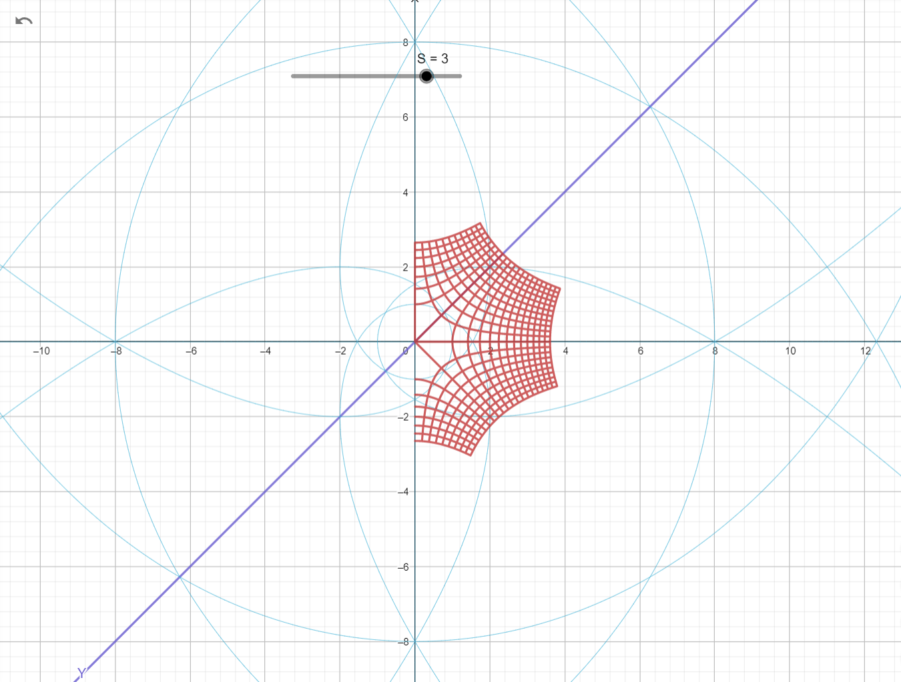

Figure (14): S = 5 still have the center unit circle for line X=1 fully bounded emerging the unit circle with origin (0.0) and radius r = 1.

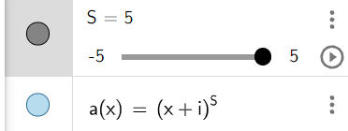

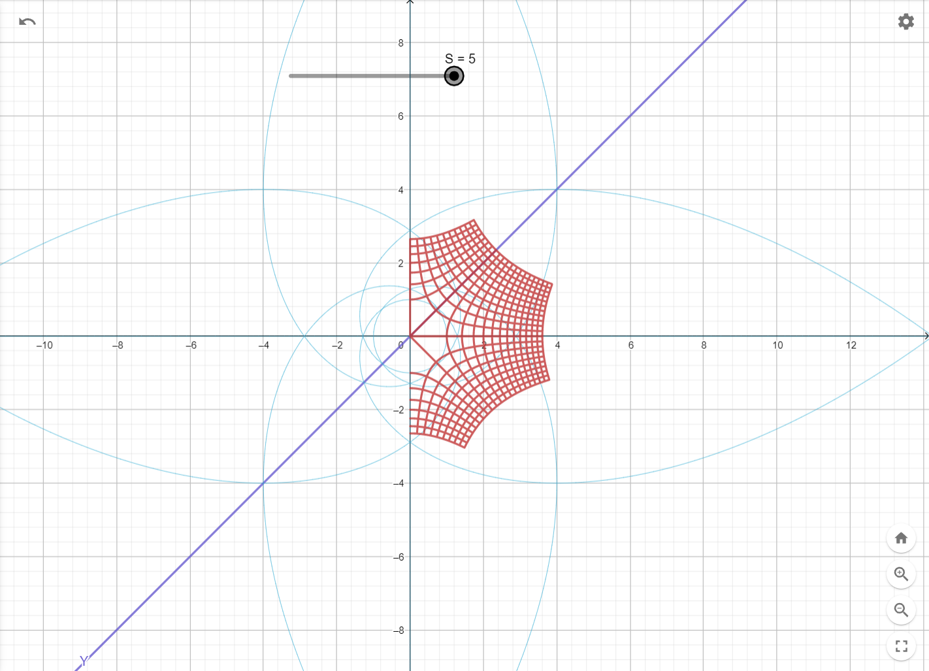

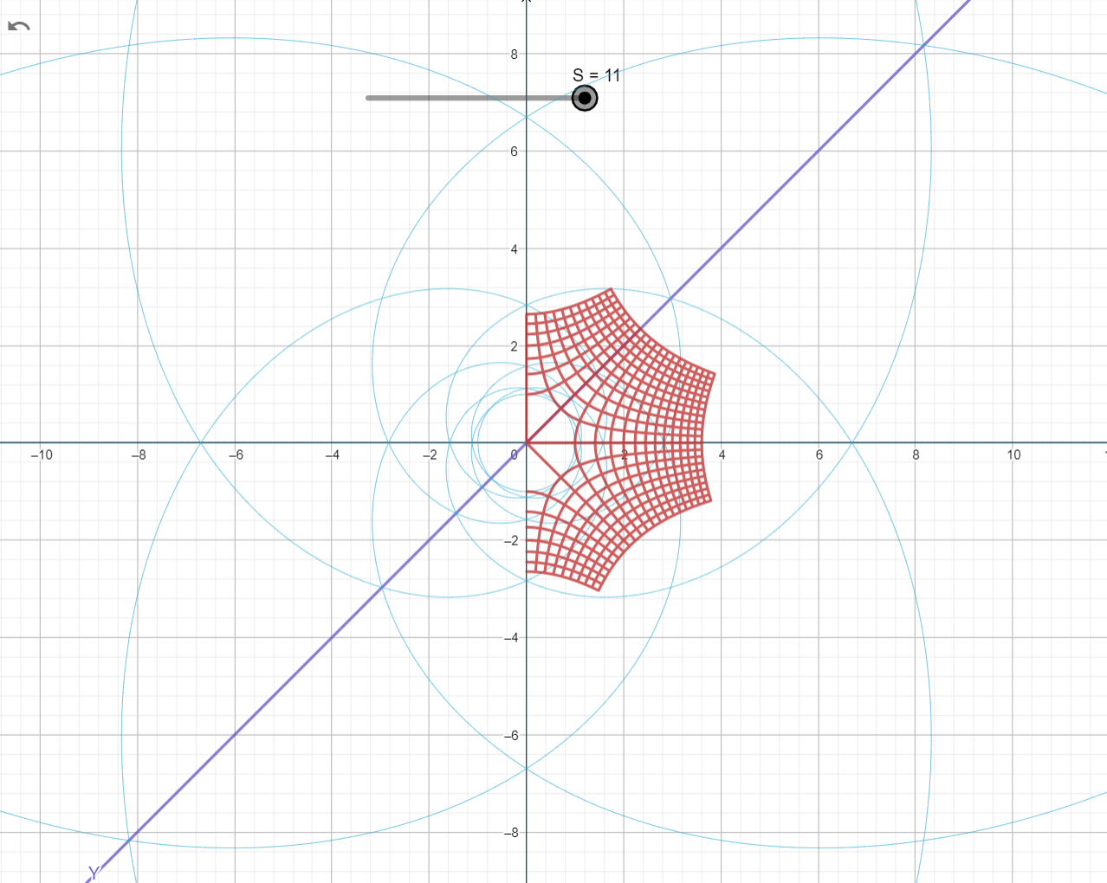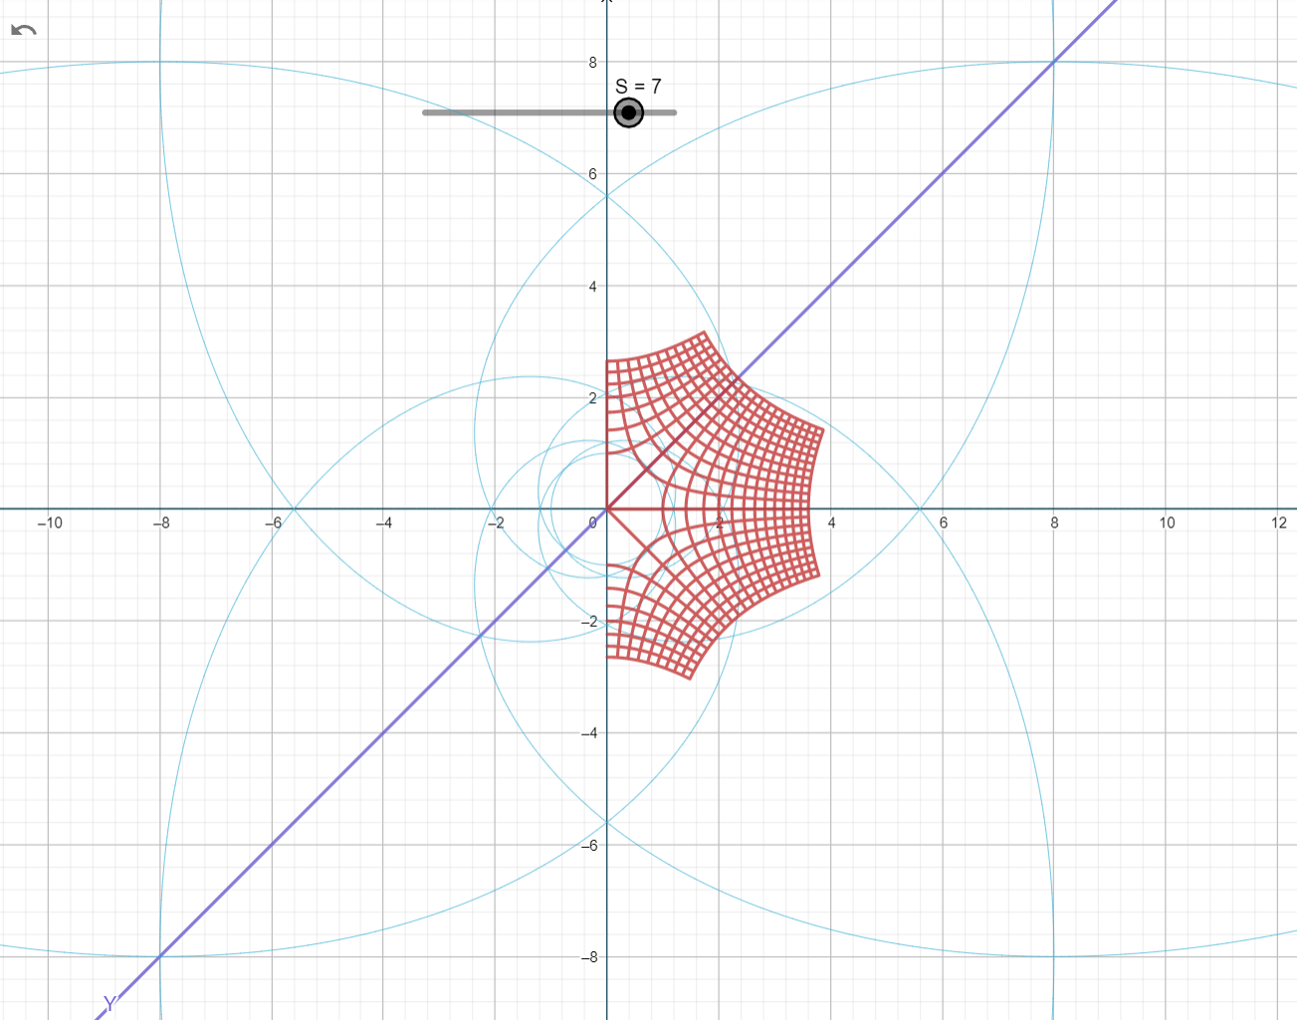Figure (15): S= 7 and S =11 and S=113 all still have the same unit Circle at center with origin (0,0) and radius = 1.

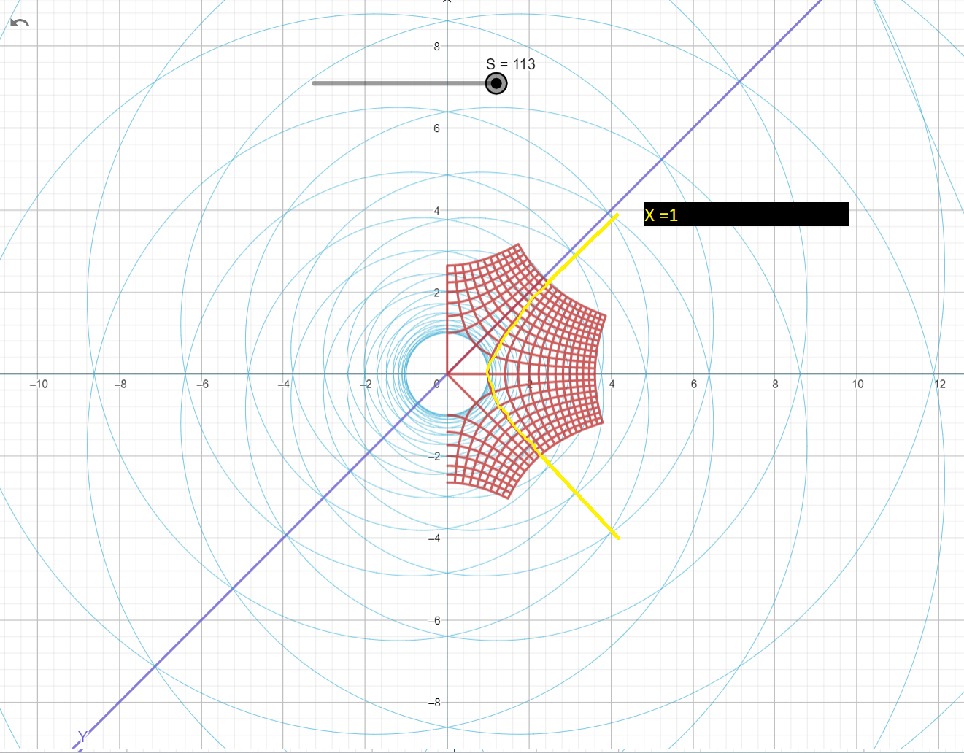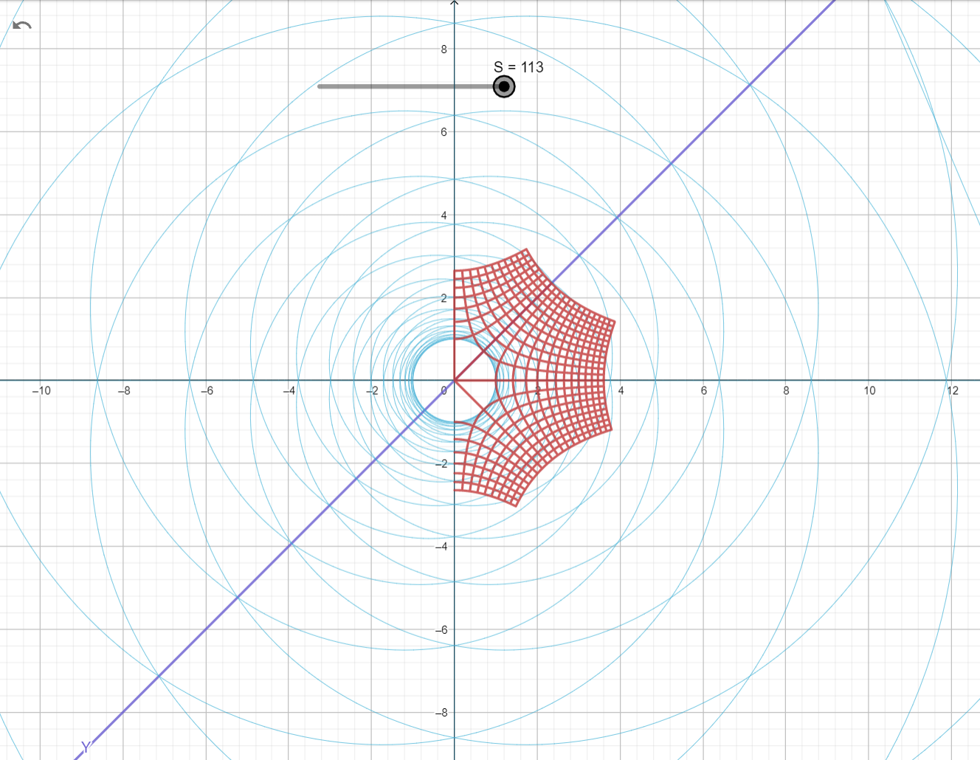

1. Base 10 number System folding in Complex plane

In base 10 we have base natural number set N = {1, 2, ,3, 4, 5, 6, 7, ,8, 9, 10}

Figure (15): base 10 number system have 10 lines (X=1, X=2, X =3, X =4, X=5, X=6 , X=7 , X=8 ,X=9 , X=10)

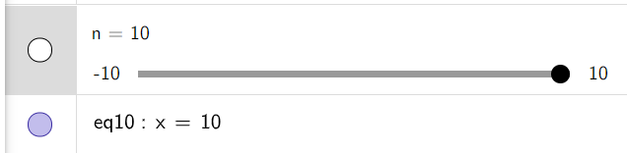

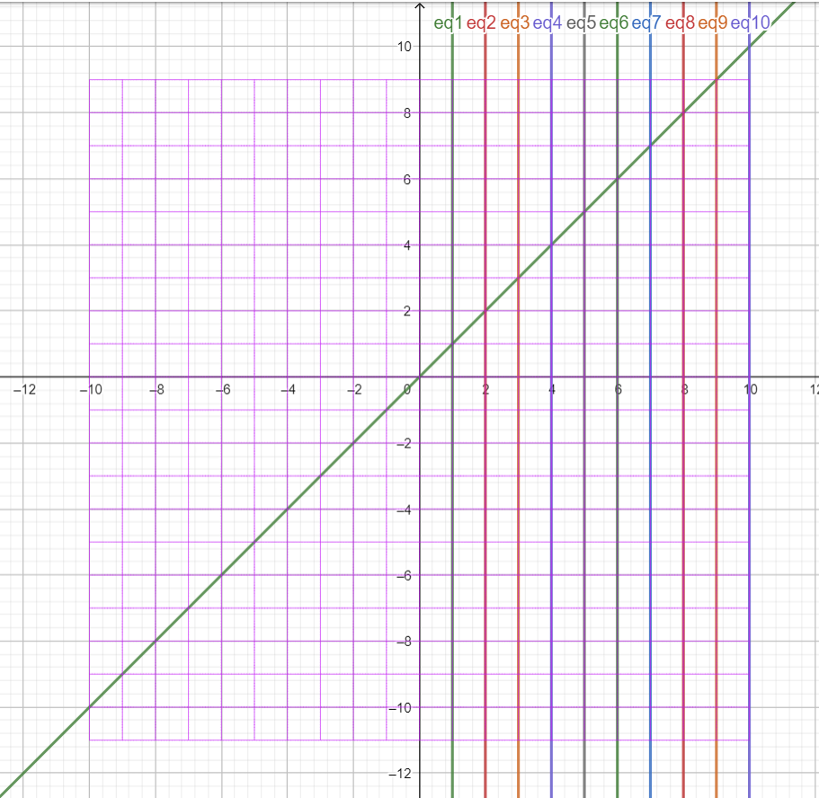

These 10 lines in base-10 number set for natural numbers set N = {1, 2, 3, 4, 5, 6, 7, 8, 9, 10} if we do one-fold in complex plane by setting S = 2. We basically doing Y = X^2

Each line will be bounded on each fold using this transformation formula

$$Y=2*N {(X+N^{2})}^{\frac{1}{S}}$$

Where N = {1, 2, 3, 4, 5, 6, 7, 8, 9, 10} and S any real Number.

Figure (16): shows that this transformation keeps the bounded lines in one-to-one relations even in higher dimension as [S=2].

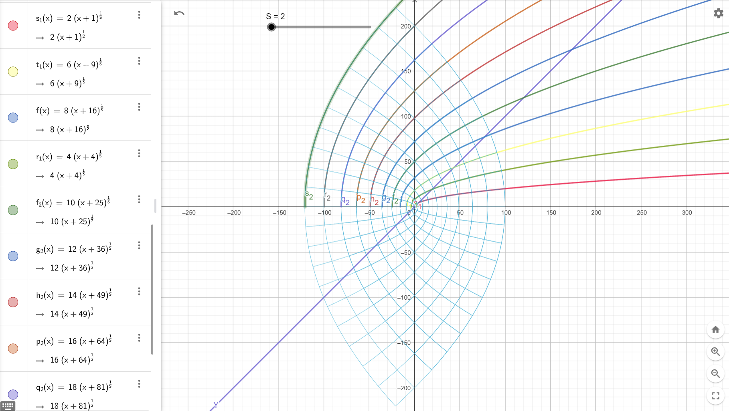

Figure (17): folding at [S=1]

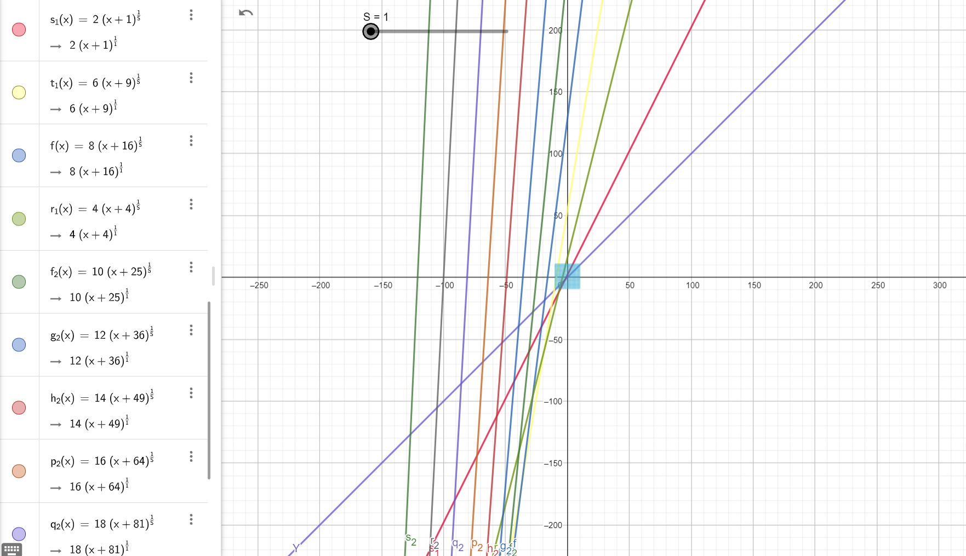

Figure (18) folding at [S=3]

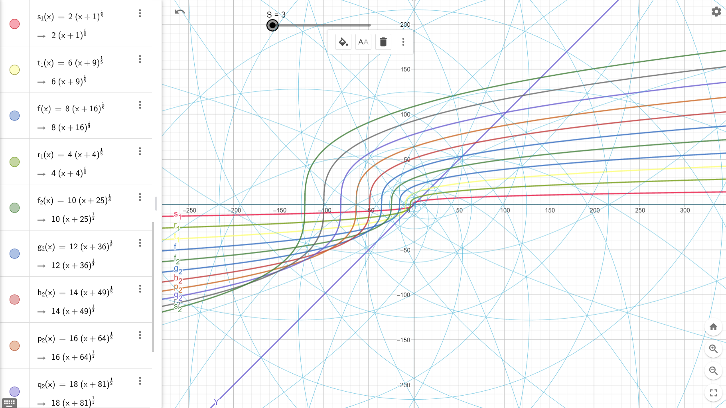

As we see in Figure (18) the folding formula is not matching exactly folded shape at the higher dimension because we missed upgrading one of the parameters in the formula to S dimension instead of S=2. So, our transformation formula should be

$$Y=2*N {(X+N^{S})}^{\frac{1}{S}}$$

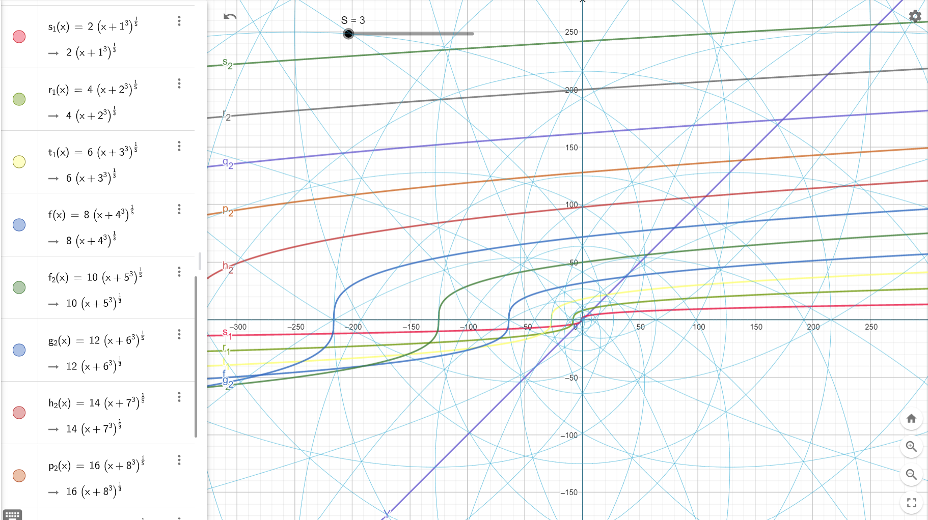

now (X+i) square lines matching exactly the points that these lines for base-10 number set intersects with X axis at N raised to the power of S.

for example: - for S = 3 in this folding X =1 will intersect X axis at X = 1\*1\*1 = 1 = 1 to the power of S where S is any real number

and X =2 will intersect with X axis at X = 2 \* 2 \*2 = 8 or 2 to the power of S, and X =3 will intersect with X axis at X =3 \*3 \* 3 = 27 or 3 to the power of S.

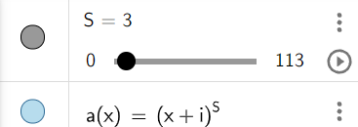

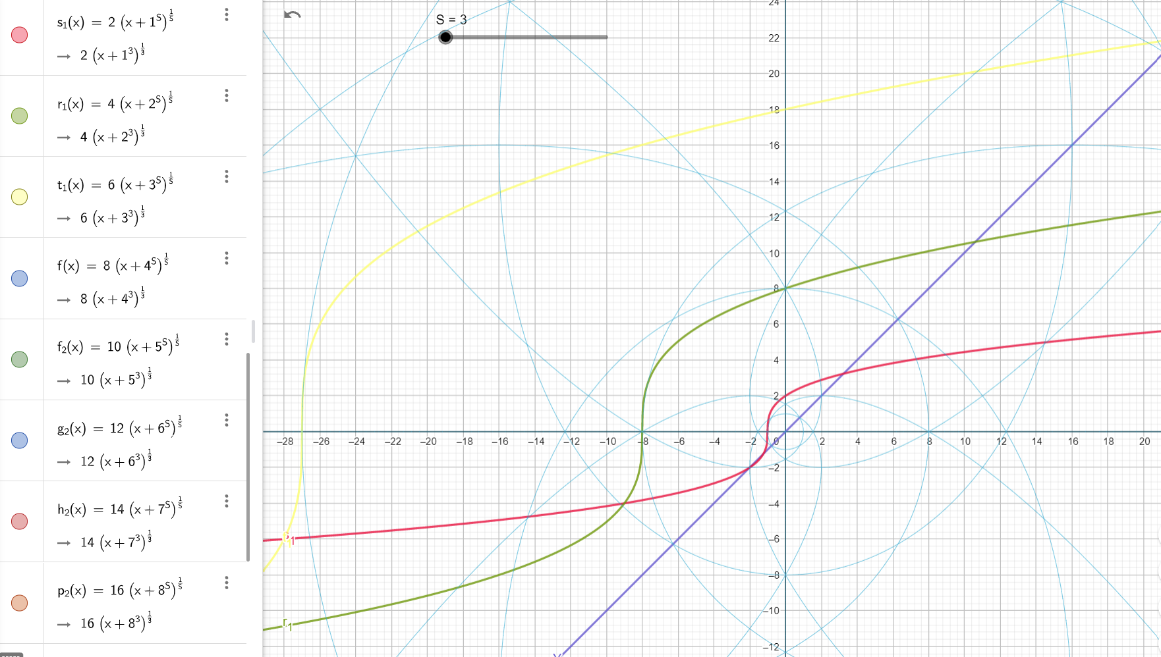

Figure (19): [S = 4] even real number, full folding shape will be at ranges of X = 10000. i.e., base-10 raised to power of S.

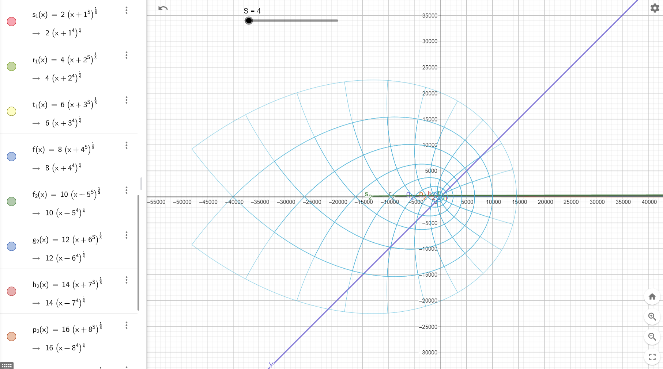

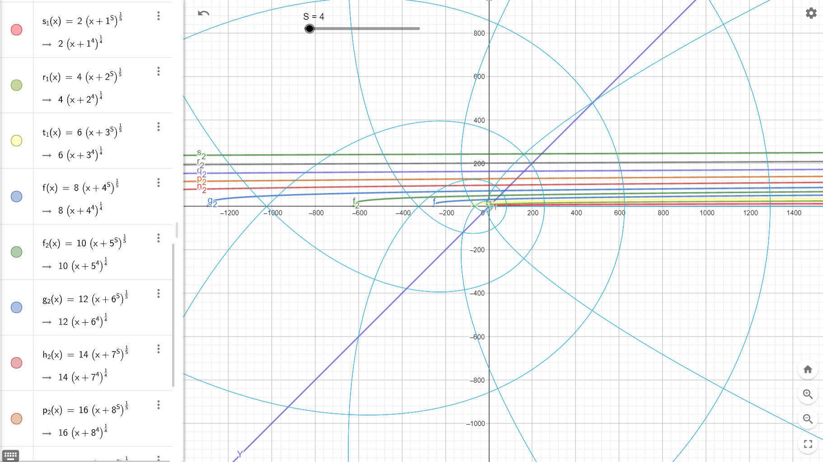

We still see the folding for square lines, but they only intersect X axis at X to the power of S and not matching the folding lines for the folded shape with small even numbers they lose the symmetry property on Y axis. The only point that meets the imaginary unit Circle at X axis is at X = 1. While odd numbers keep its symmetry on both X and Y axis.

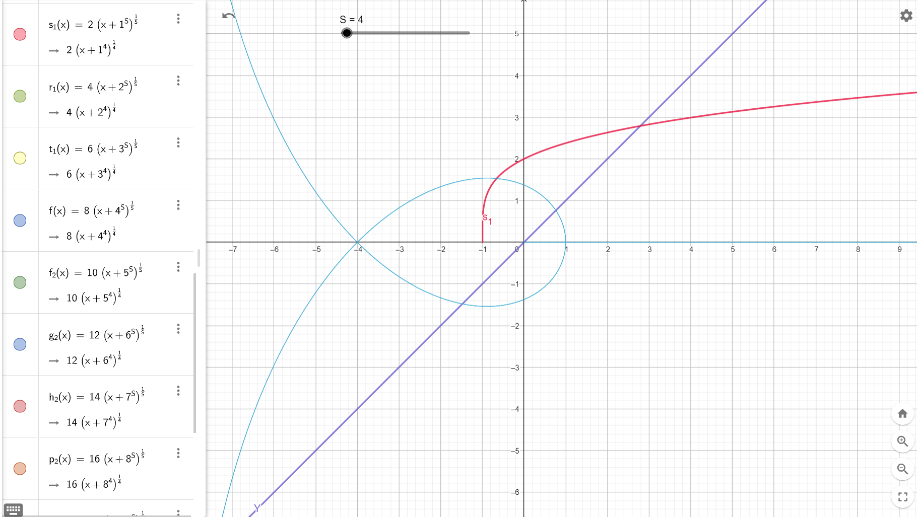

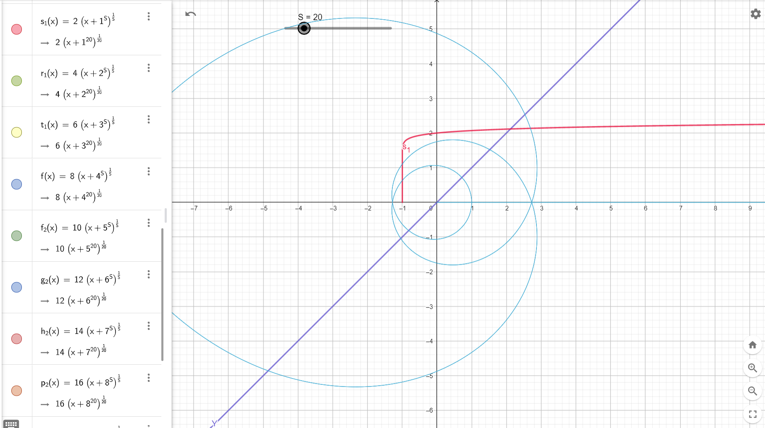

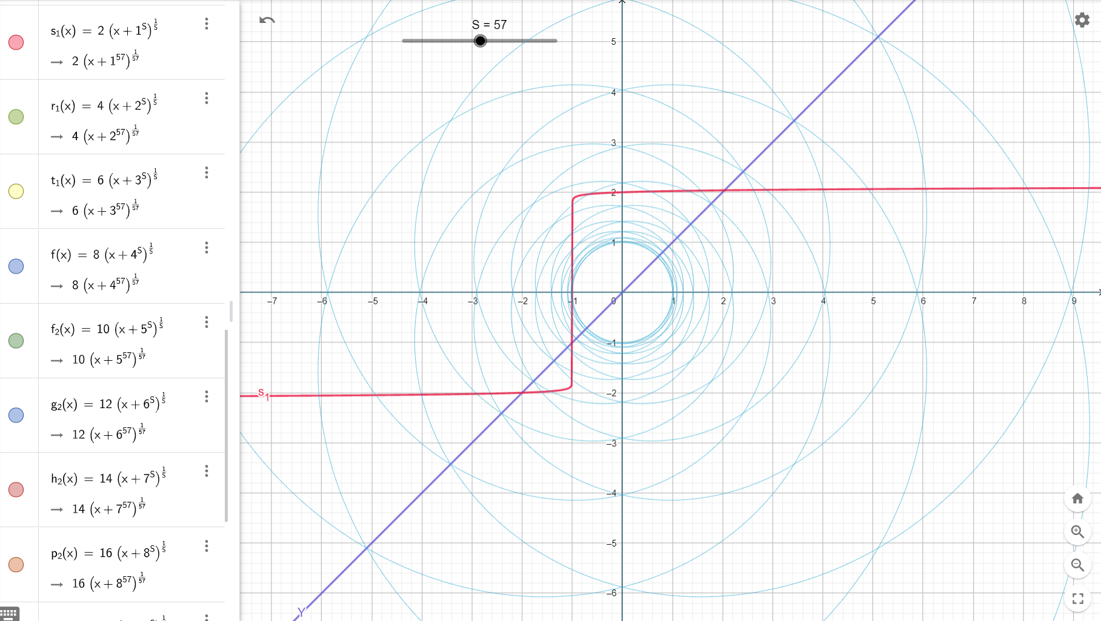

Figure (20): [S=5] full 2-D shape folded unit square will be at range of X = 100000.

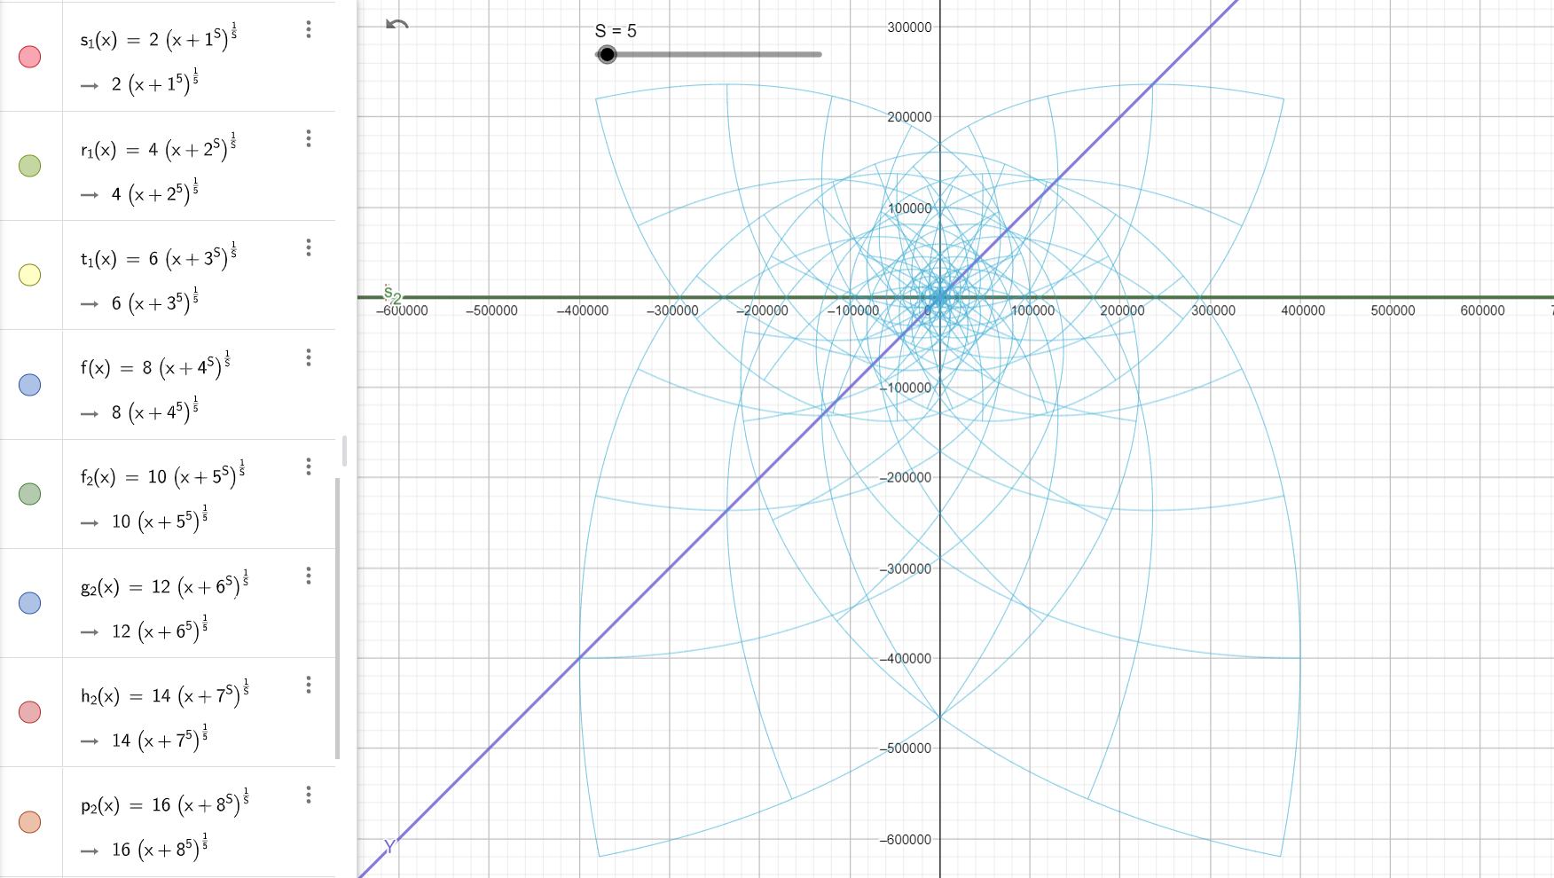

Still, we have the one unit at the tip of the shifted from Y=X the one-to-one relation

As we saw in figure (9) the full folded shape for [S=3] is the same as the full folded [ S =5] but flipped on X axis



Which is means odd numbers will have two folds one on Y axis and another one on the X axis all the time which what gave us the symmetry on Y axis and Y axis and give us the full shape symmetry and flipping and emerges the unit circle at origin (0,0).

Figure (21): [S =7] full 2-D fold shape will be at range X = 10000000. Or 10 to the power of S.

Same one unit shift still exists at the tip point of the full shape to meet Y = X line.

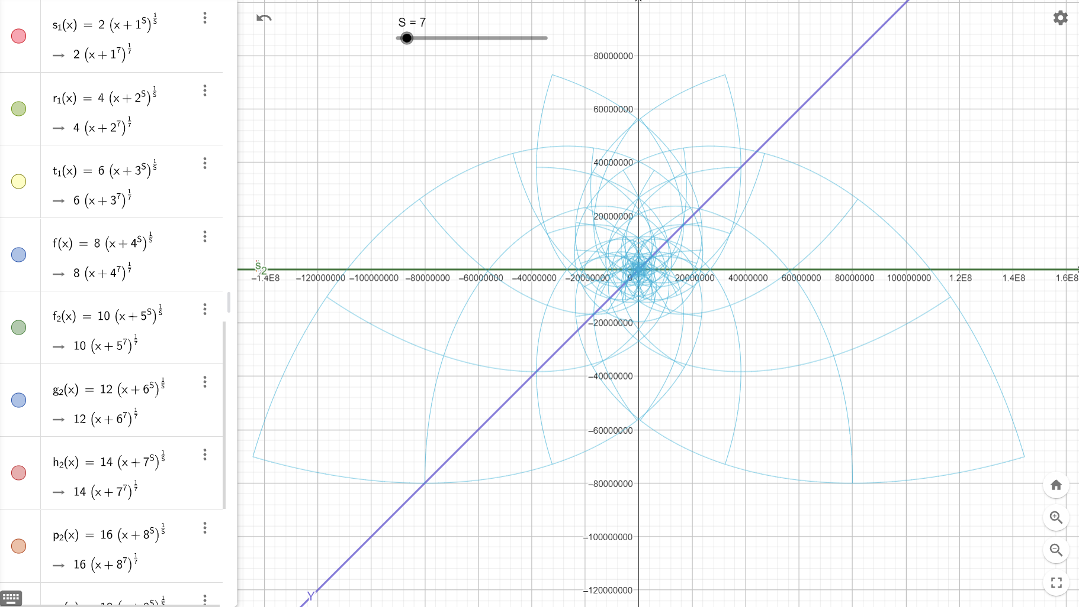

For [S =9] full fold 2-D shape will be in X range = 10 to the power of 9.

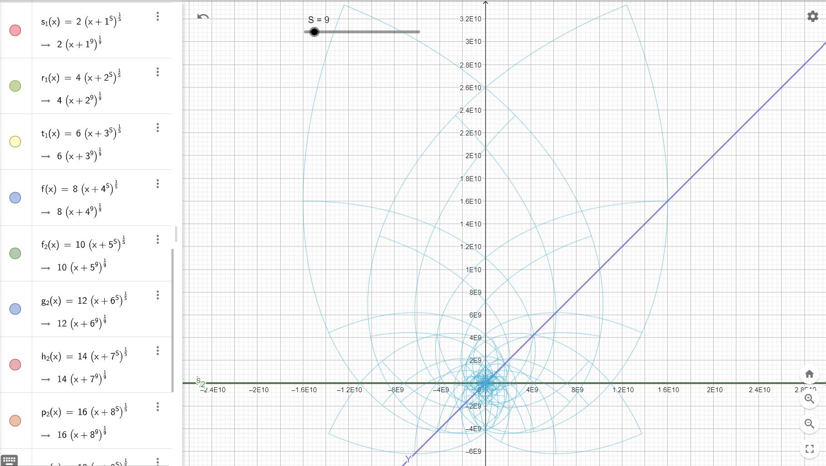

For [S =11] full 2-D shape will be in X range = 10 to the power of 11

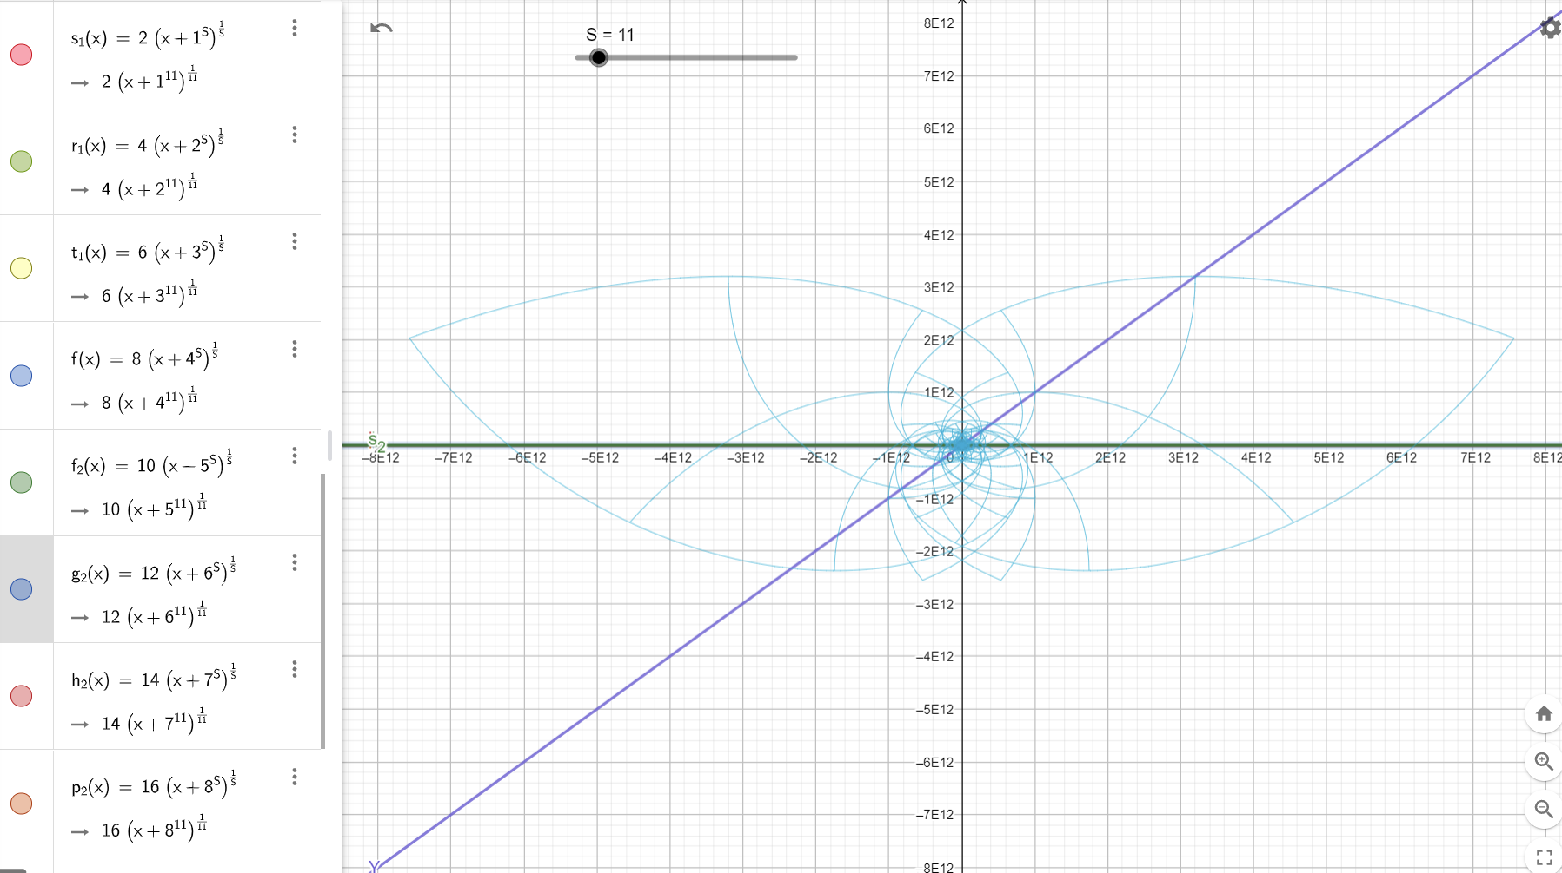

For [S = 12] full 2-d shape will be in X rang = 10 to the power of 12.

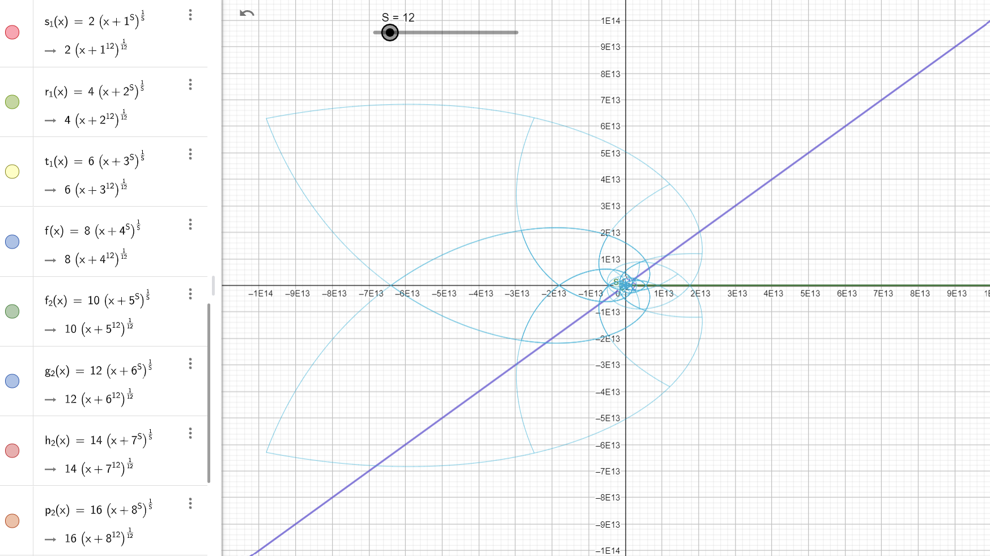

1. Y value when X =0 for any folding order and for any real value for S at any dimension N.

As we saw at [S=2] transformation formula

$$Y=2*N {(X+ N^{S})}^{\frac{1}{S}}$$

This transformation will set us on the unit Circle in complex plane for all points N =1 line X=1 in unit square. Intersect Y axis at Y = 1 for X =0.

Same for the invers of this transformation for any real value for S $$Y={(N^{S}*X+ N^{S})}^{\frac{-1}{S}}=\frac{1}{N}{(X+1)}^{\frac{-1}{S}}$$

This is basically the same transformation but for 1/S instead of S.

This transformation for X = 0 will give us Y = 1/N all the time. So all time the intersection with Y axis will be at point (0, 1/N ) for any natural number N.

Figure (22): all lines X =N , with this transformation will intersect Y axis at point 1/N

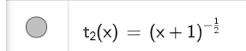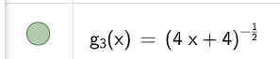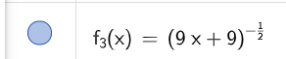

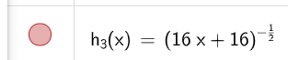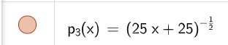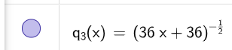

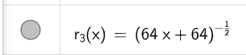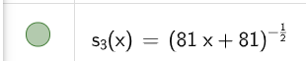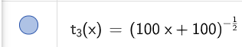

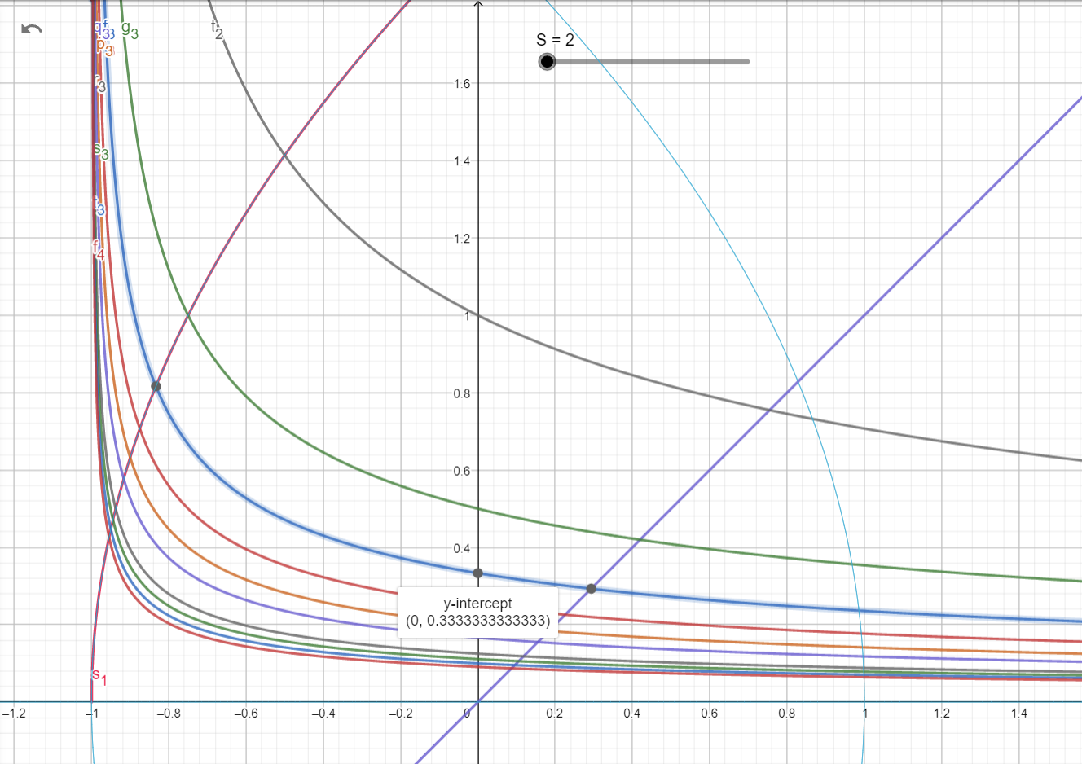

This means for each new fold we have 1/N for each line.

So instead, we are going to use this transformation remove this 1/N for any N as S < N.

$$Y={(N^{S}*X+ 2^{S})}^{\frac{-1}{S}}$$

Figure (23): all N lines X =N and S = 2; all will intersect with Y axis at 1/S instead so intersect point (0,0.5)

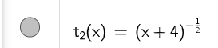 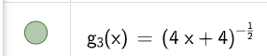 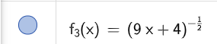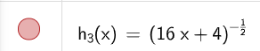 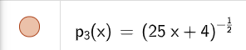 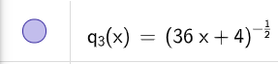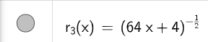 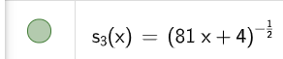 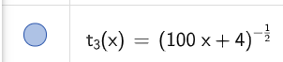

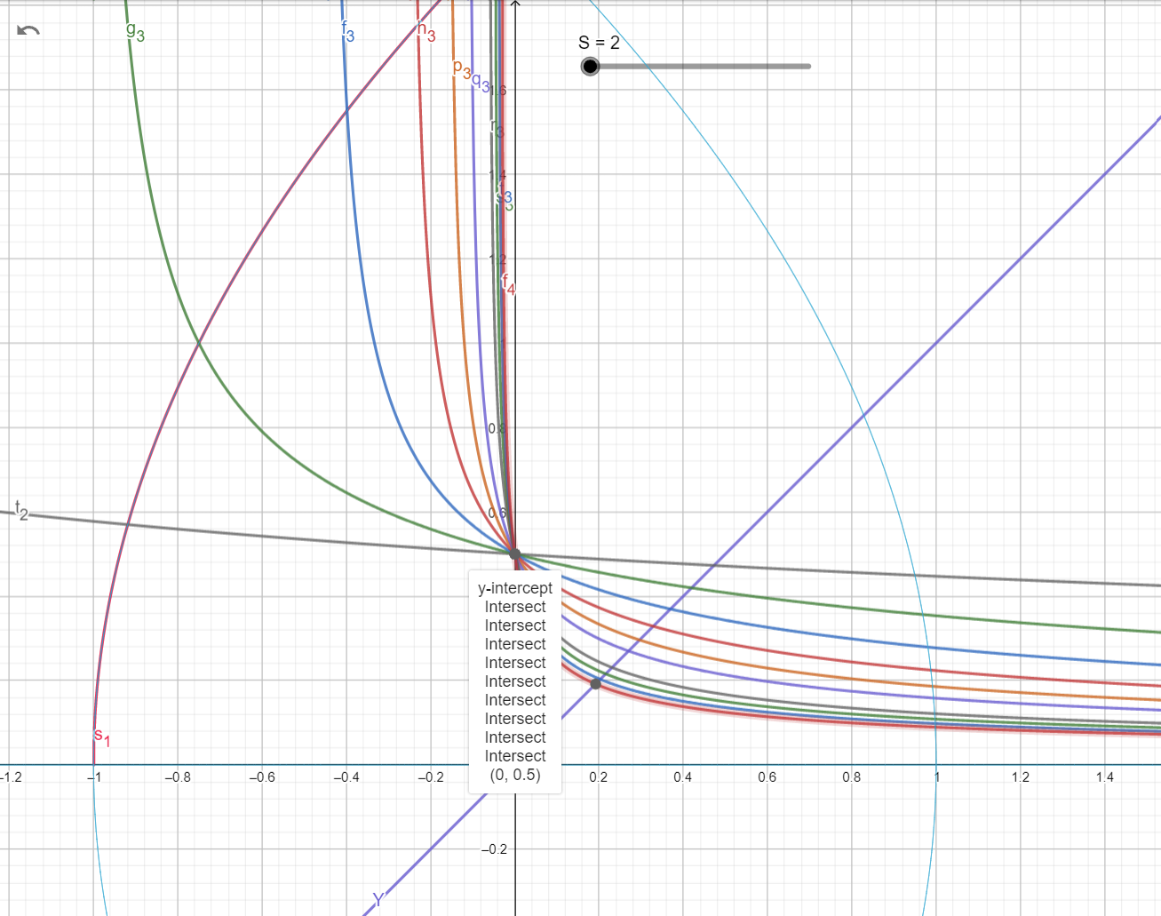

Figure (24): [S =3] all line numbers X =N intersects with Y axis at point (0, 0.5)

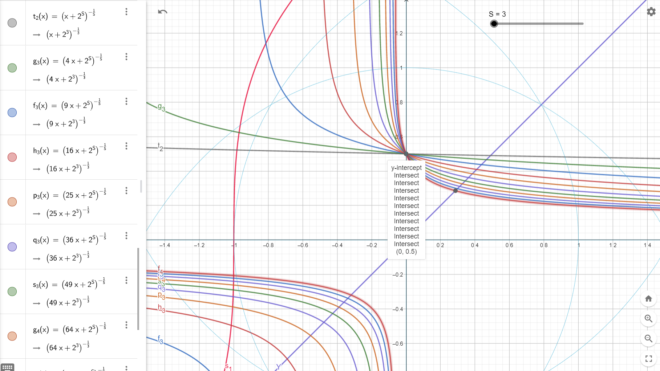

Figure (25): [ S =5] all line numbers X =N intersect with Y axis at point (0,0.5)

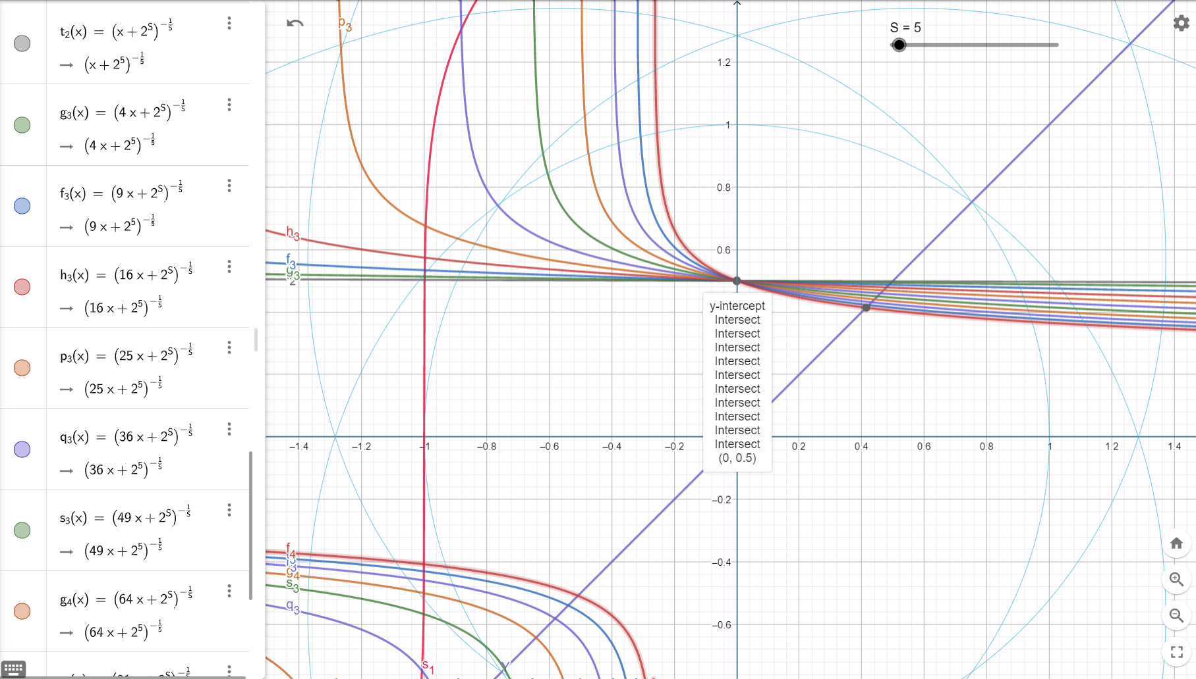

Figure (26) ): [ S =73] all line numbers X =N intersect with Y axis at point (0,0.5)

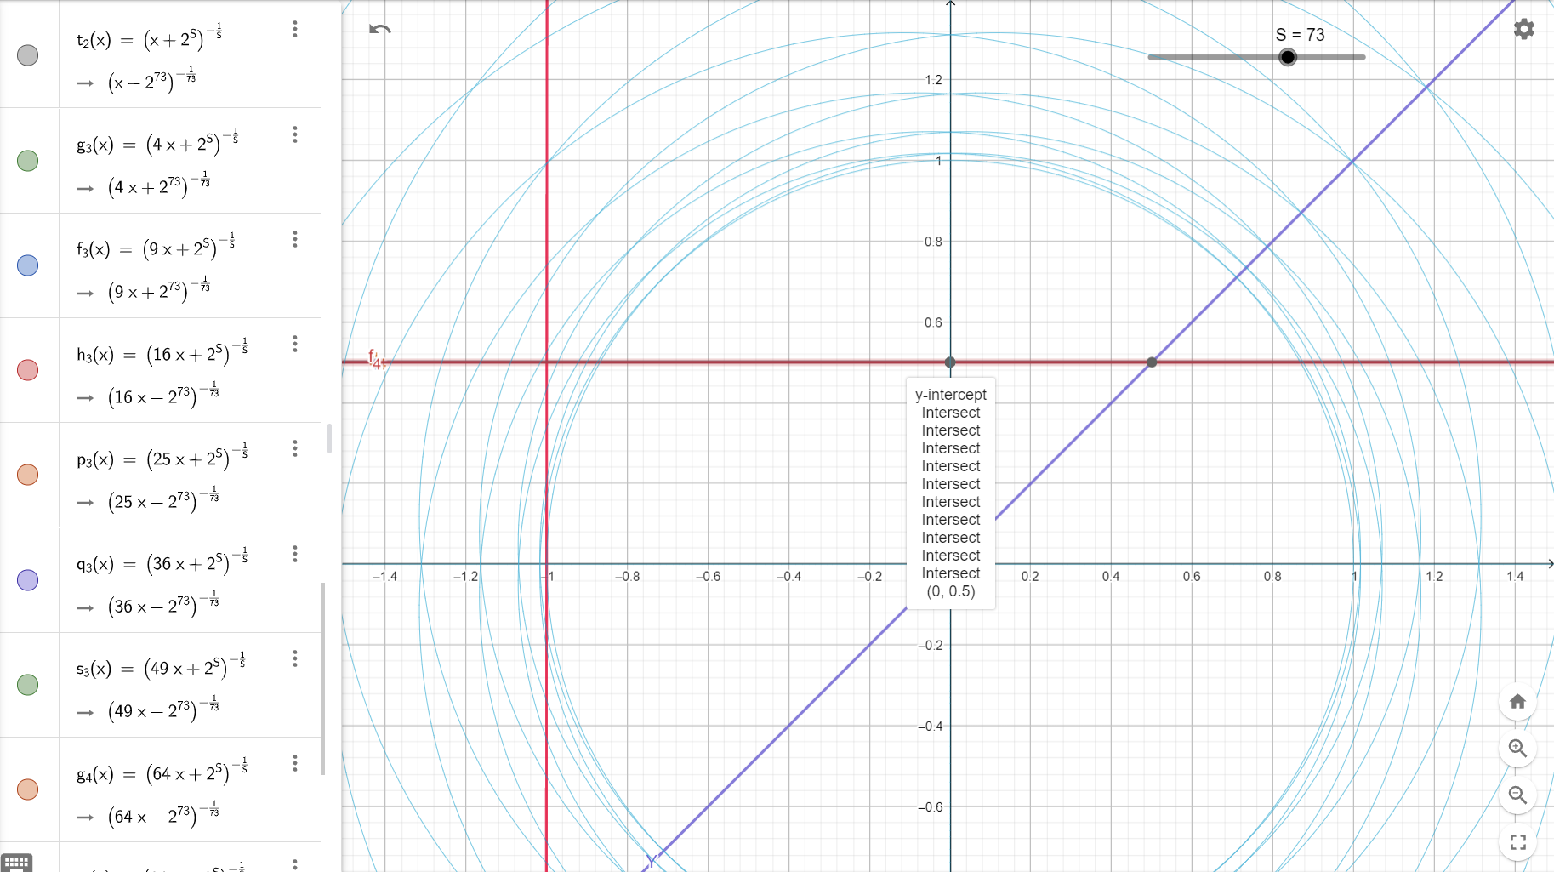

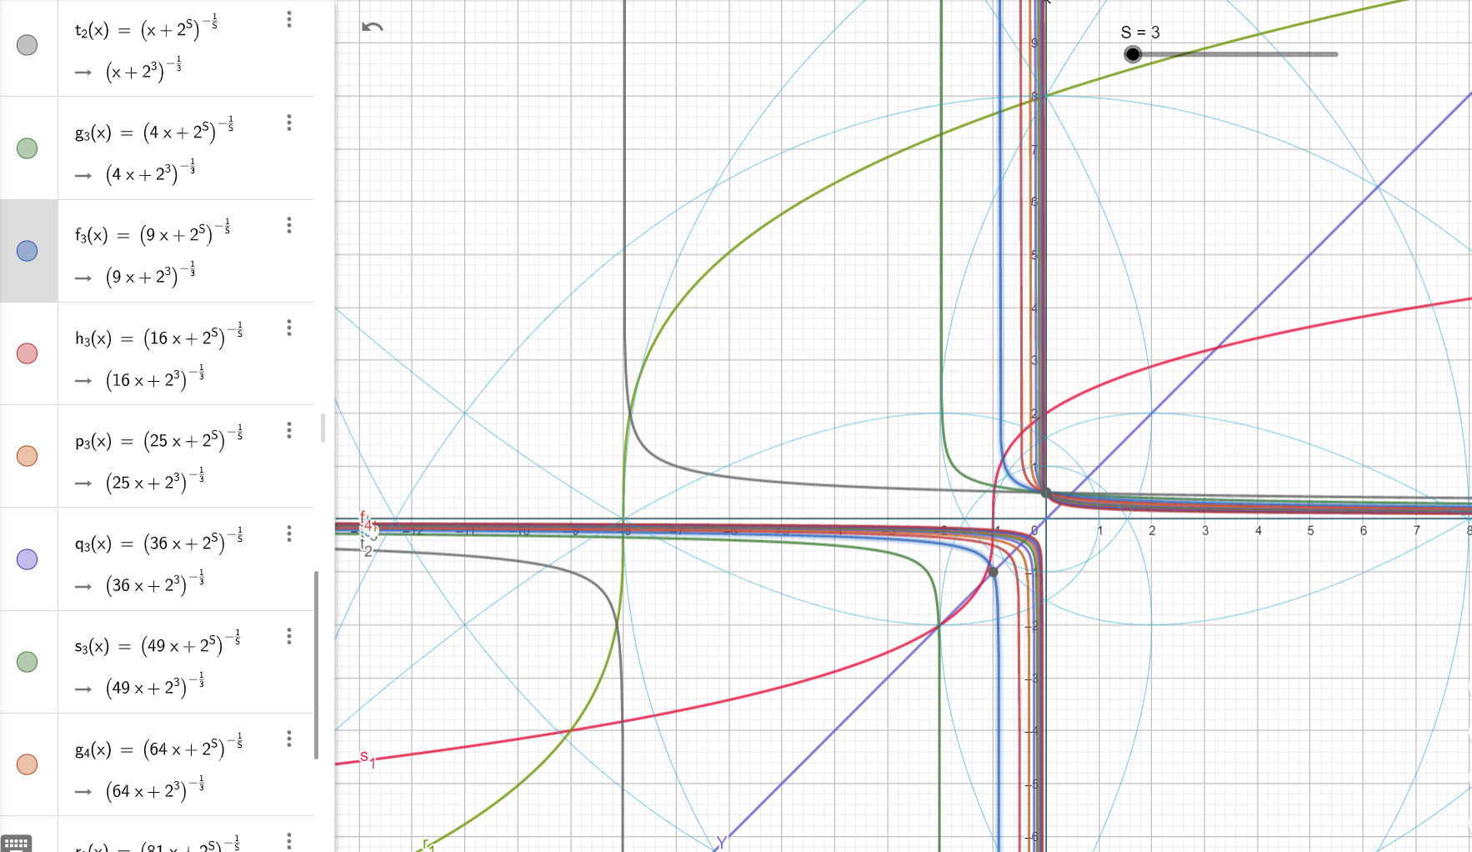

We can do the same transformation $$Y={(N^{S}*X+ 2^{S})}^{\frac{-1}{S}}$$

Using this formula as well

$$Y=\frac{N}{2}{(N^{S}*X+ N^{S})}^{\frac{-1}{S}}= \frac{1}{2}{(X+ 1)}^{\frac{-1}{S}}$$

And this is the same transformation as

$$Y=2*N {(X+ N^{S})}^{\frac{1}{S}}$$

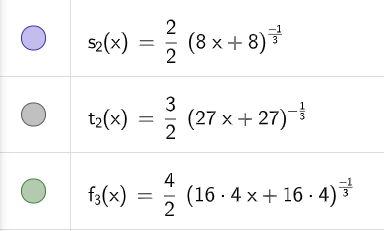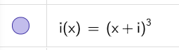

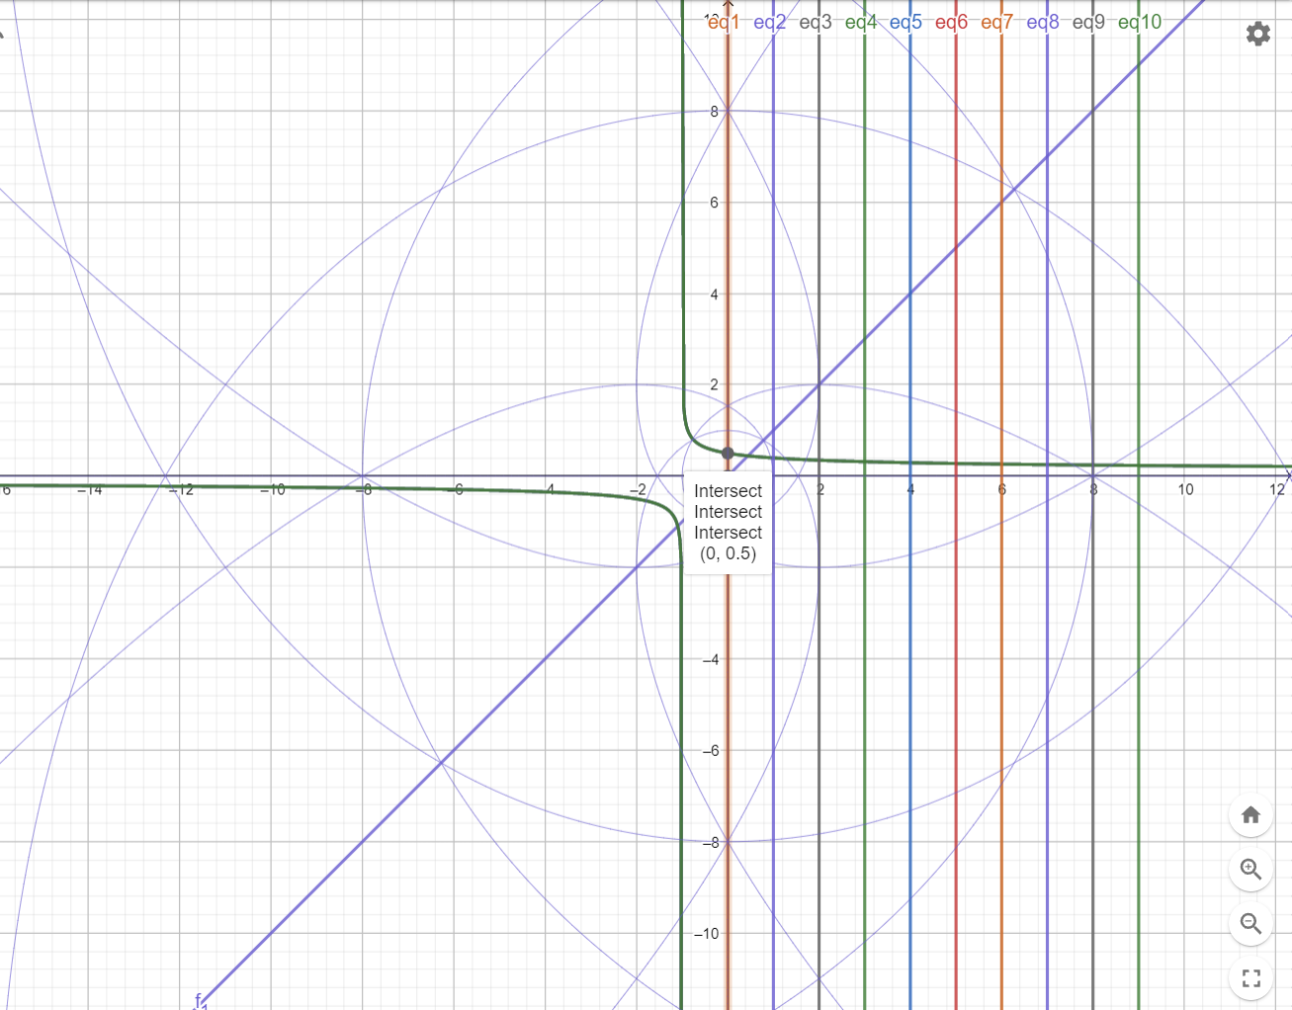

For N =1 and S = 2; $Y=2*N {(X+N^{S})}^{\frac{1}{S}}$

$$Y=2 \sqrt{(x+1)}$$

For N =1 and S = 2; $Y={(N^{S}*X+ 2^{S})}^{\frac{-1}{S}}$

$$Y=\frac{1}{\sqrt{X+4}}$$

For N =2 and S = 2; $Y=2*N {(X+N^{S})}^{\frac{1}{S}}$

$$Y=4 \sqrt{(x+4)}$$

For N =2 and S = 2; $Y={(N^{S}*X+ 2^{S})}^{\frac{-1}{S}}$

$$Y=\frac{1}{\sqrt{4X+4}}$$

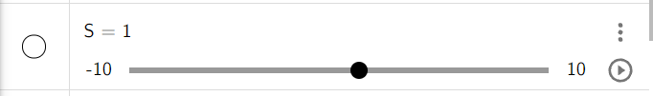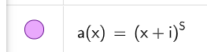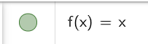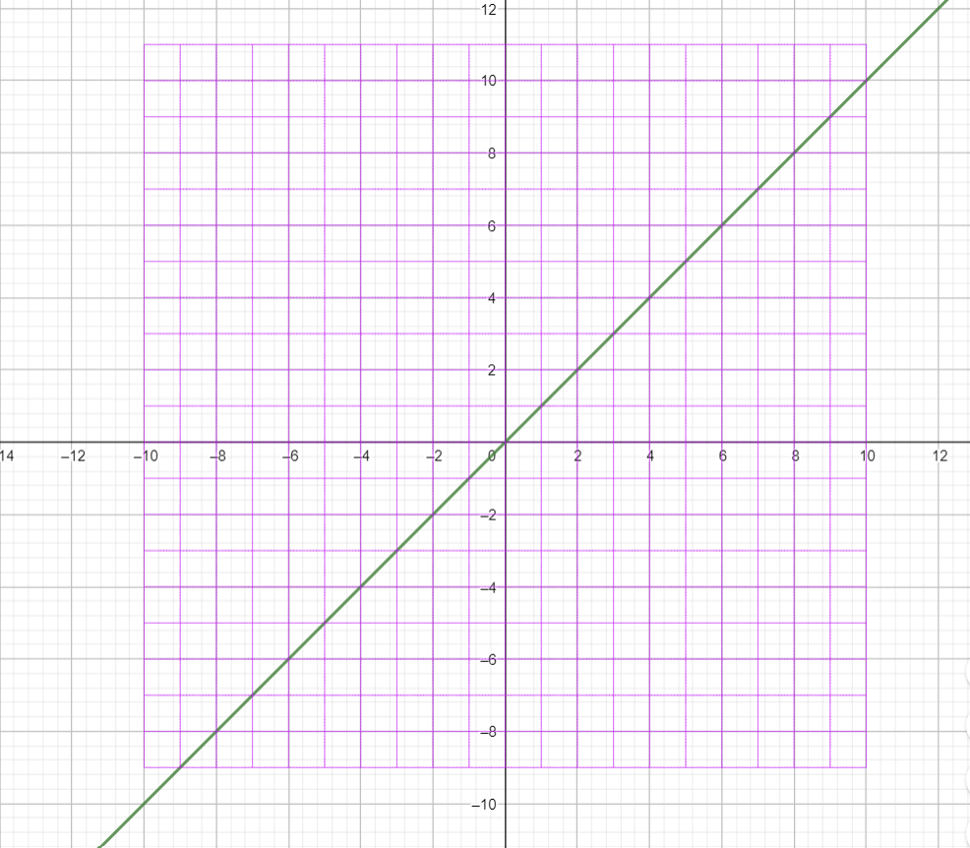

1. Vertical axis Y [], Horizontal axis X []
2. To have Y =X as a square diagonal, this square needs to be shifted to right one unit.

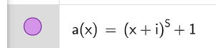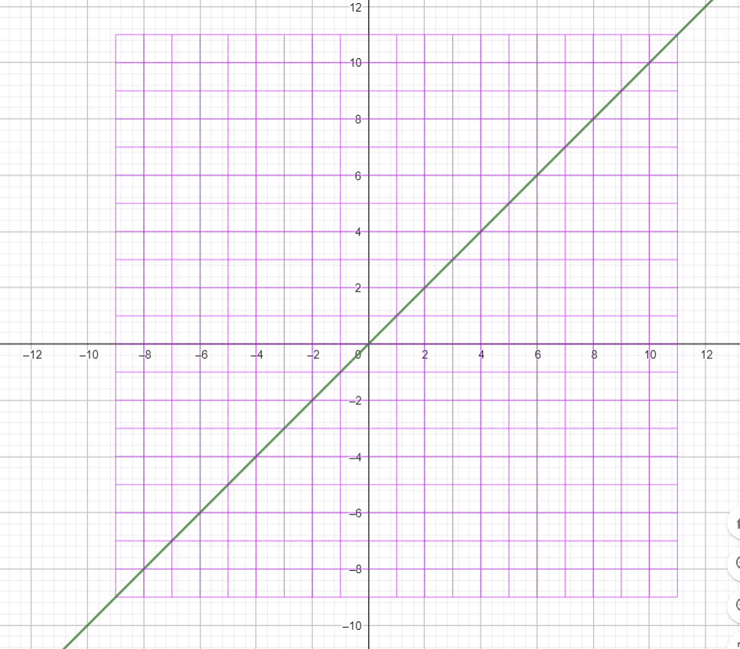

1. Now Y =X is a square diagonal, but the square is asymmetric on Y axis now due to this one unit shifted in square
2. In our frame of reference after this shift, now a(x) square has 11 Horizontal lines on left +ev side of Y axis and 9 lines on right -ev side of Y axis.

Same will be for [-i] we need to remove one from frame of reference to have Y=X as square diagonal

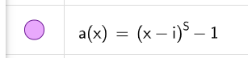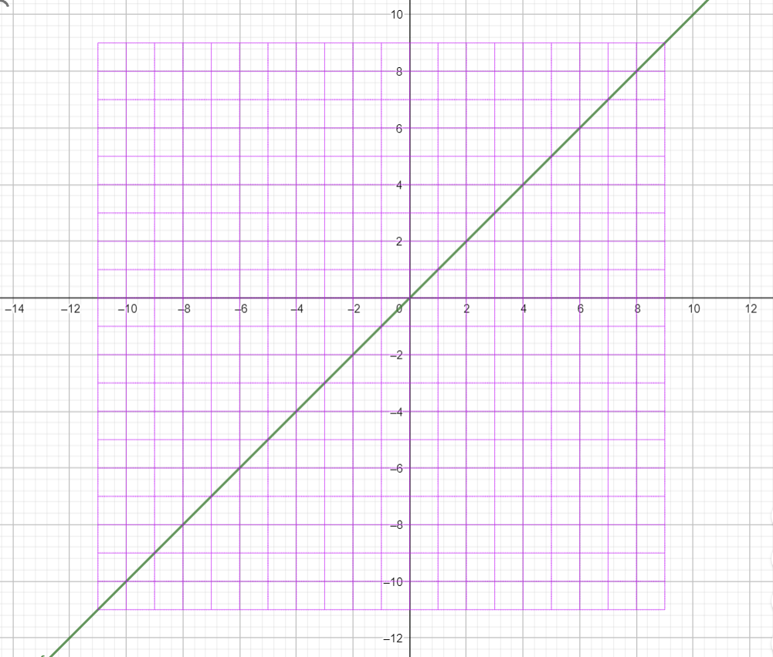

1. We are using base 10 number system so our frame of reference is square of 400 square units.
2. These 400 square units are the result of the intersection of X = N and Y =N where

N = [-10:10] any natural number between and include {-10 ,10} as we see here the lines for X=N

1. Each Vertical line X = N; we will represent one dimension. i.e., X =1 this is the first dimension.

X= 2 this is the second dimension; X=3 this is the third dimension. Until last dimension 10.

1. The square origin (0,0) is not on the fist dimension X =1 and this what makes Y=X is not the square diagonal.
2. To fix this shift we need to subtract one from our frame of reference; but this will make our square diagonal Y =X will be at Y =X + 2

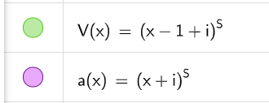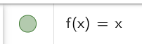

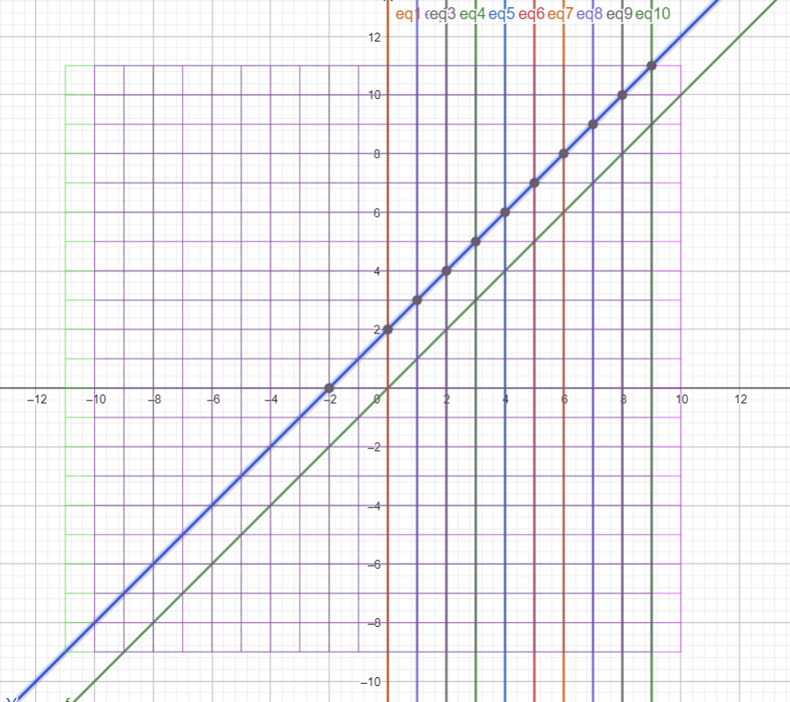

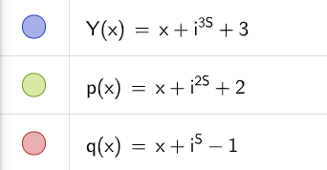

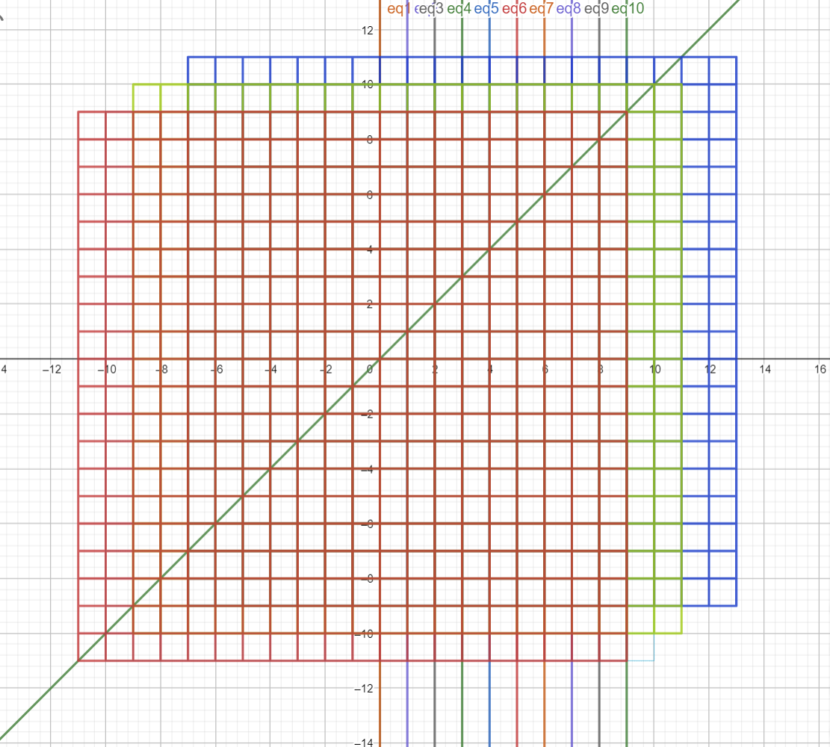

Now we need to fold Y = X after it is at square diagonal

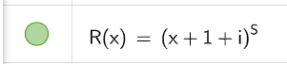

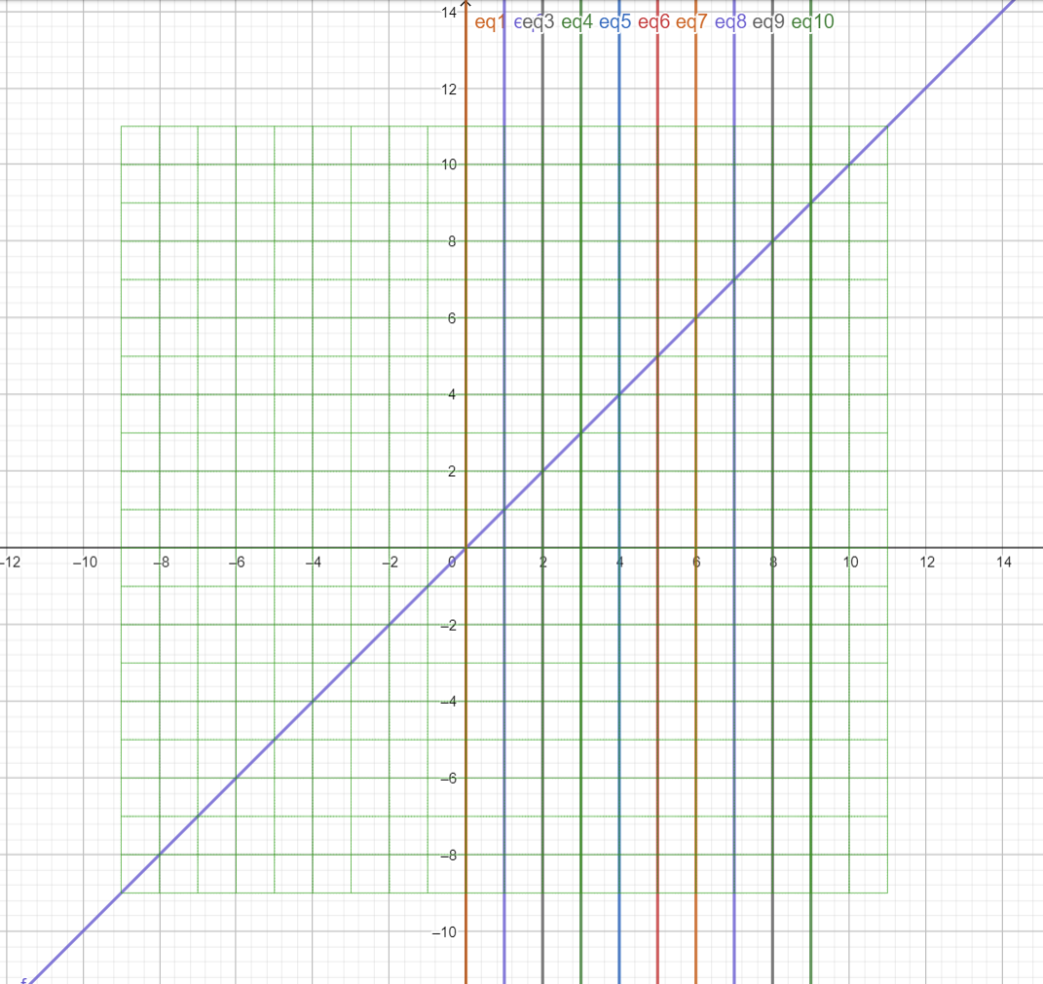

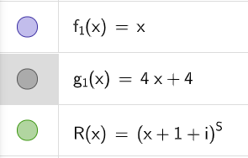

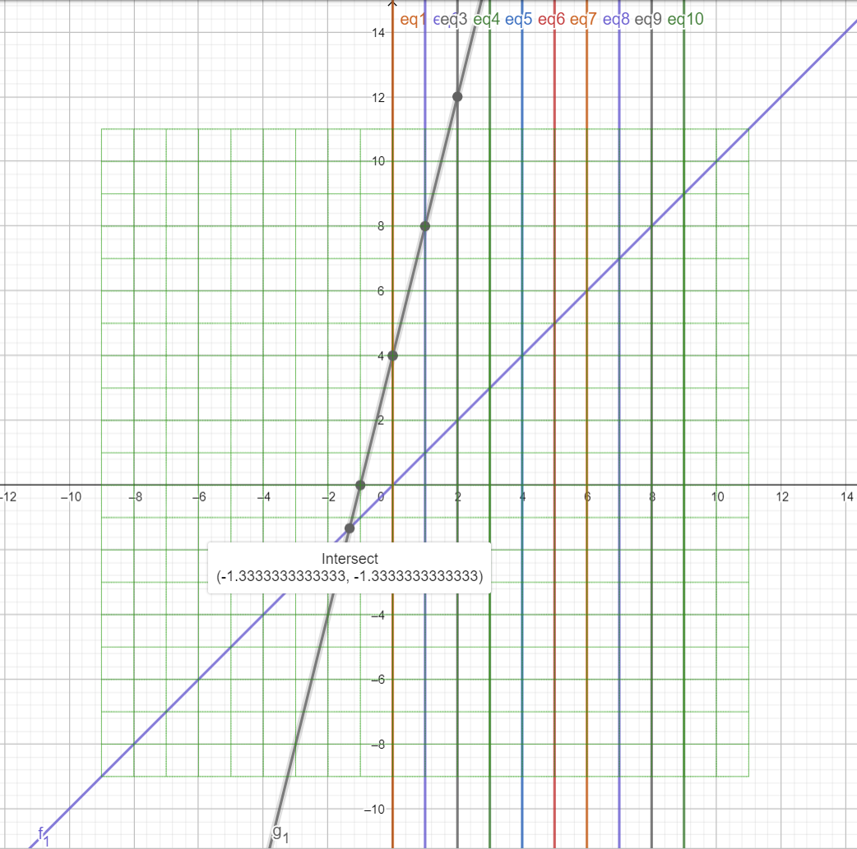

First dimension fold for N = 1

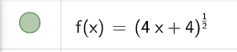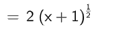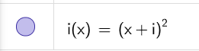

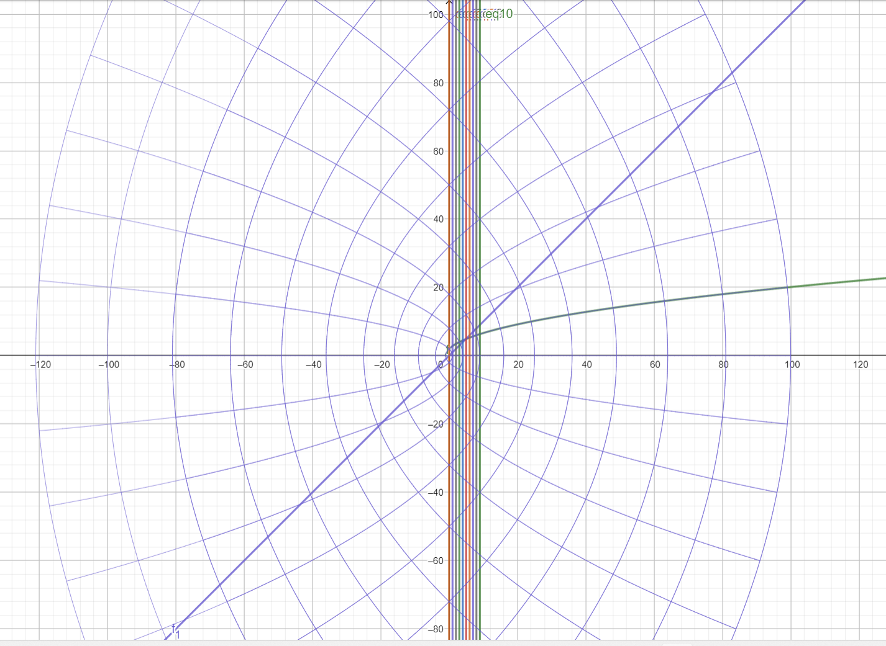

Fold for dimensions N = 1, N = 2, N =3, N =4 using this formula

$$Y= 2N\sqrt{X+N^{2}}$$

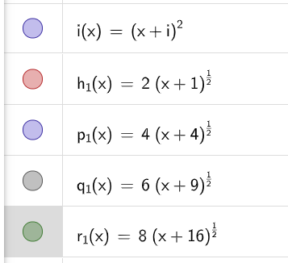

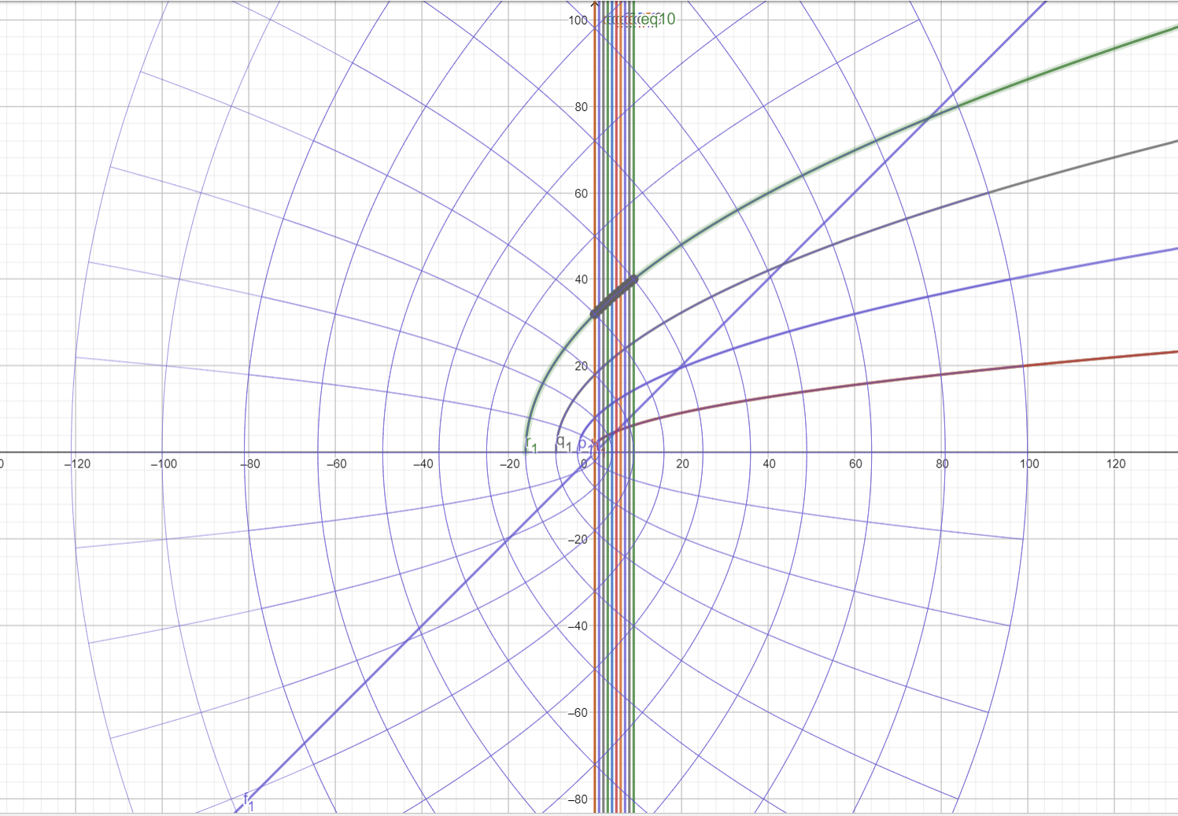

The inverse of these transformation (folding) for dimensions N = 1, N =3, N=5, N=7 …

All intersects at Y = 0.5 and X = 0 $$Y= \frac{1}{\sqrt{N^{2}X+4}}$$

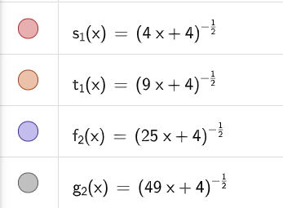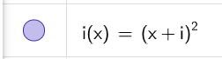

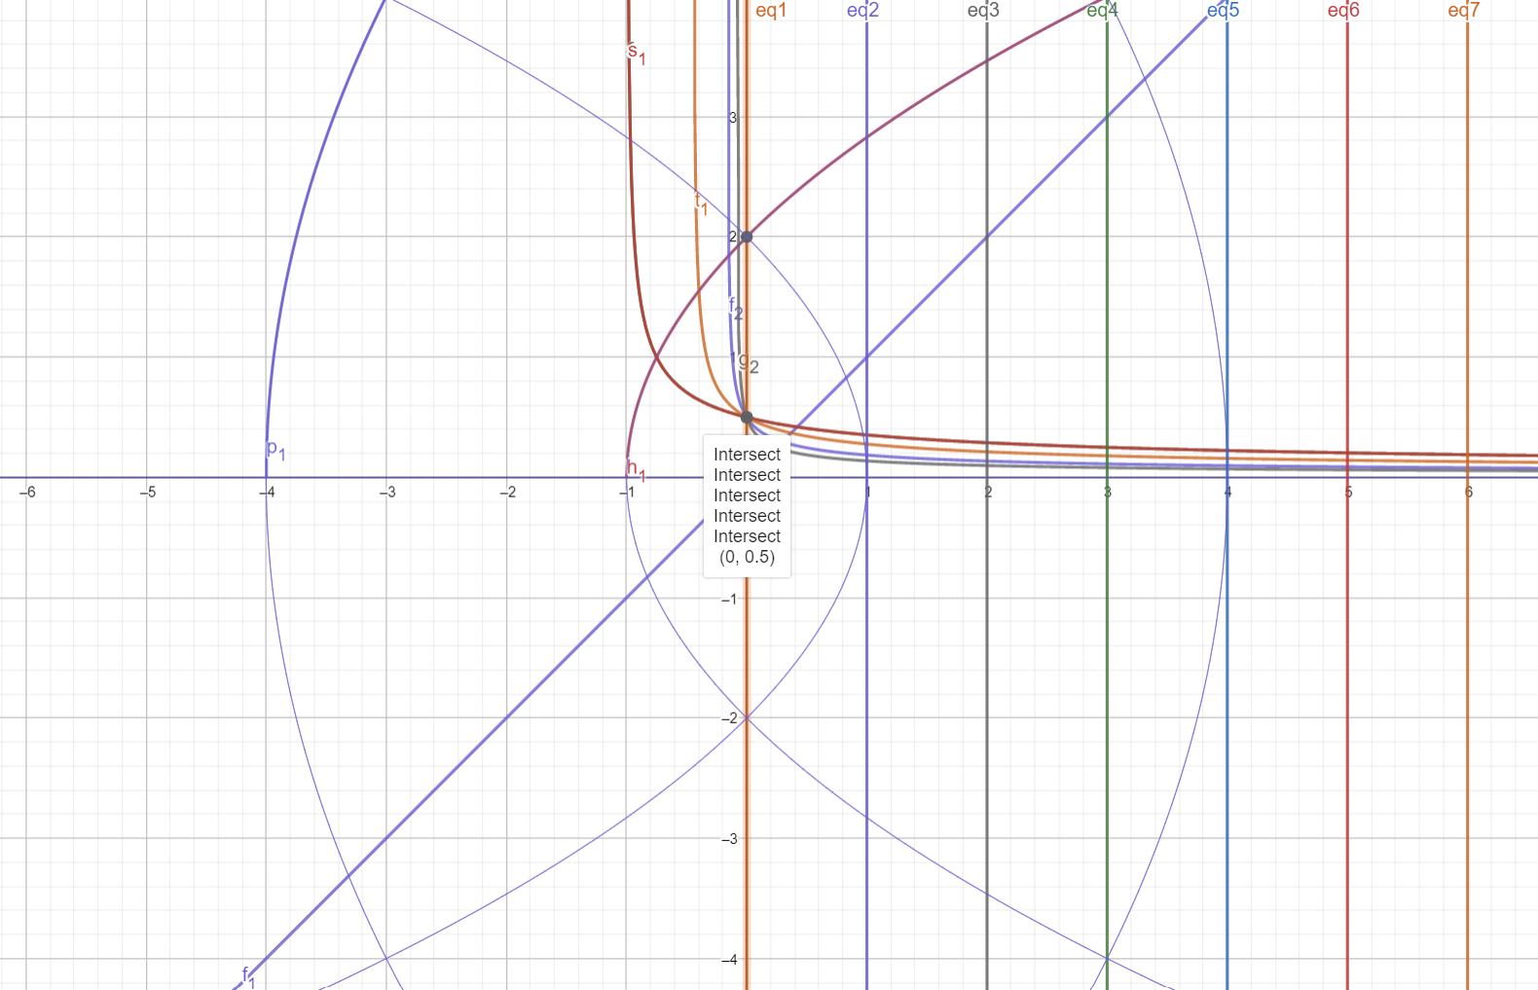

Now we are going to move in time dimension where S = 3

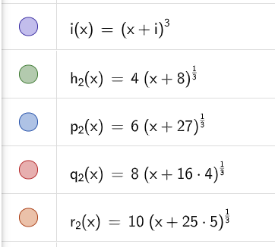

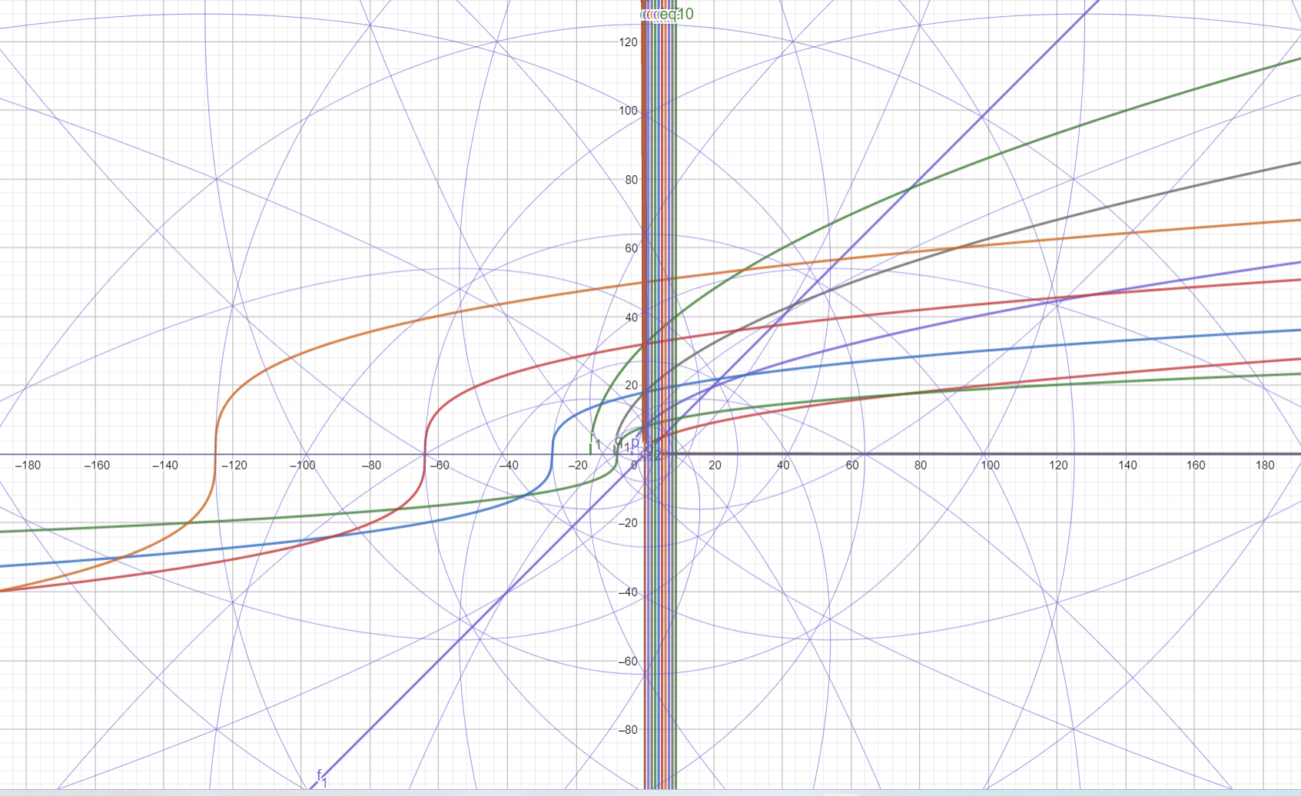

Invers of this main fold for Dimension N =3 will also Y intersect at Y =0.5 and X=0



